Billie Jo (Harmon) Mooneyhan
March 16, 1938 – January 6, 2020

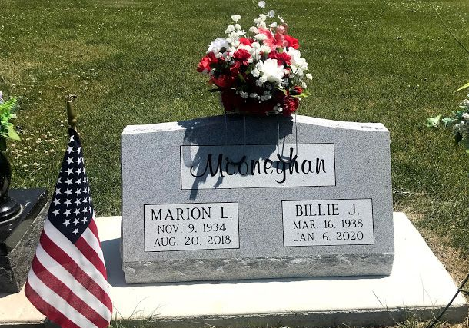
Photo by SMMR

Billie Mooneyhan, 81 years of age of Pikeville passed away Monday January 6, 2020 at the Parkview Nursing and Rehabilitation Center. She was born on March 16, 1938 to the late Willie and Dessie Parks Harmon. She was a homemaker.
Other than her parents she was preceded in death by her husband; Marion Mooneyhan, one son; Ron Mooneyhan.
She is survived by her daughter; Debbie Thomas of Pikeville, three sisters; Barbara Mooneyhan, Wanda Snyder, Ruby ______, three grandchildren; Matthew Thomas, Jennifer Thomas, Mark Thomas and one great-grandchild; Kaden Thomas.
A private memorial service will be held at a later time.

Hall & Jones Funeral Home, Virgie, Kentucky
**

Billie J. Mooneyhan, 81 years of age of Pikeville, Kentucky passed away Monday, January 6, 2020 at the Parkview Nursing and Rehabilitation Center. She was born on March 16, 1938 to the late Willie and Dessie (Parks) Harmon. She was a homemaker.
Other than her parents she was preceded in death by her husband; Marion Mooneyhan, one son; Ron Mooneyhan.
She is survived by her daughter; Debbie Thomas of Pikeville, three sisters; Barbara Mooneyhan, Wanda Snyder and Ruby, three grandchildren; Matthew Thomas, Jennifer Thomas, Mark Thomas and one great-grandchild; Kaden Thomas.
A graveside service will take place at 2 P.M. on Saturday (January 11, 2020) at Fairview Cemetery in Bluffton with Jeff Lemler officiating.

Thoma/Rich, Lemler Funeral Home, Wells County, Indiana

