Terry L. Miller
October 18, 1951 – February 22, 2017

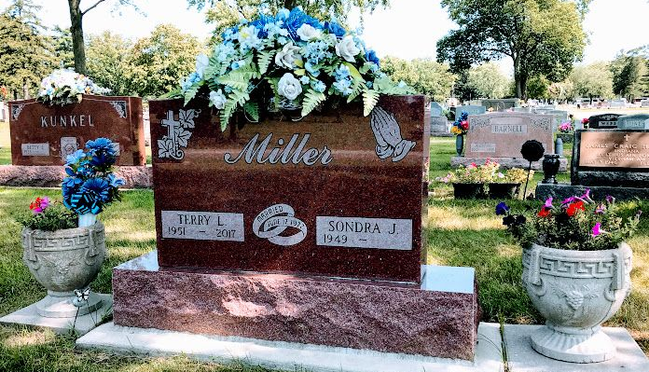
Photo by SMMR

Terry L. Miller, 65, of Montpelier, IN, passed away on Wednesday, February 22, 2017 at Lutheran Hospital of Indiana in Fort Wayne. He was born on Thursday, October 18, 1951, in Wells County, IN. He married Sondra Jo (Kunkel) Miller on Saturday, June 17, 1972 at the Park United Brethren Church, Bluffton, IN. Terry was a 1971 graduate of Bluffton High School. He drove a fork truck for Metaldyne in Bluffton, IN. He was a collector of baseball cards and coins. Terry enjoyed spending time with his family.
Loving Survivors Include: Wife - Sondra Jo (Kunkel) Miller, Montpelier, IN, Son - Tony Ray (Jennifer) Miller, Montpelier, IN, Daughters - Tammy Nicole (Eddie) Hodge, Edinburgh, IN, Shanda Nicole Miller, Montpelier, IN, Brother - Larry (Dawn) Miller, Bluffton, IN, Sisters - Carolyn (Tom) Davis, Michigan, Diane Pence, Indianapolis, IN, and 2 Grandchildren.
He was preceded in death by his parents Howard Edward and Nellie Wuanita (Bennett) Miller.
Family and friends may gather to share and remember at Walker & Glancy Funeral Home 109 W. Windsor St. Montpelier, IN on Sunday February 26, 2017 from 2:00 PM to 6:00 PM. and one hour prior to service on Monday February 27, 2017. A service to celebrate Terry’s life will be at Walker & Glancy Funeral Home at 11:00 AM on Monday February 27, 2017 with Tim Wallace officiating. Interment will follow in the Fairview Cemetery in Bluffton.
Preferred memorials: First United Methodist Church, 215 E. Green St., Montpelier, IN 47359 or American Diabetes Association, 6415 Castleway W. Dr., Indianapolis, IN 46250

Walker & Glancy Funeral Home, Montpelier, Indiana
February 23, 2017

