Michael Miller
September 30, 1809 – November 25, 1893

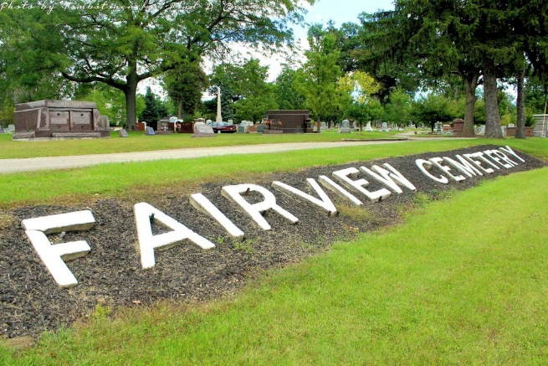
Photo by Tombstoner & Family

THE FIRST CITIZEN
Michael Miller The First Settler of Bluffton Goes To His Rest
Full of Years, He Is Gathered Home Like A Sheaf Fully Ripe

Michael Miller was born in York county, Pennsylvania, September 30, 1809. He emigrated with his parents to Baltimore county, Maryland, and after residing there four years, removed to Fairfield county, Ohio. He returned to Pennsylvania in 1819 where he learned the carpenter's trade. While there he helped to build a bridge across the Big Brandywine at Downing Town. He returned to Lancaster, Ohio, in 1832. After remaining there one year and in the prime of young manhood, and desire of adventure, he emigrated to the now thriving city of Ft. Wayne, Indiana, then only a small village.
In 1836 he returned to Ohio where he was married to Louise Gary and immediately came to Wells county entering land in section 36 Union township, adjoining where the town of Uniondale is now situated. At that time, what is now Wells county, was a trackless wilderness, abounding with all kinds of game. He built a small cabin or shed with one side open, in which a 'log-heap' burned to keep warm. There with his young wife, he commenced life's journey, depending on the game in the immense forest for a living. In 1836 he sold his land and moved to Bluffton and built the old Franklin House, where he kept "Tavern" for fifteen years. He served three terms as sheriff of the county.
His wife died in October 1864 and he was married to Lucy Miller in 1865, who still survives to mourn his loss. His family consisted of seven children, four of whom have preceded him in death. The others, W. B. Miller, of Andrews; Mrs. J. H. Clifton, of Hartford City, and Mrs. Henry Fisher, of Marion, who were present at the time of death, which occurred at 7 o'clock p.m. November 25th, 1893. He was 84 years, 1 month, 25 days.
His funeral occurred at the Methodist church Monday at eleven o'clock. Rev. Wade preached a very able and comforting sermon. Aside from the many relatives present, the audience was composed largely of gray haired men and women, neighbors who had known and esteemed the deceased for many years. His remains were laid to rest in Fairview cemetery.

Bluffton Banner, Wells County, Indiana
Wednesday, Nov. 29, 1893

