Marie A. (Harden) Miller
September 3, 1892 – January 3, 1975

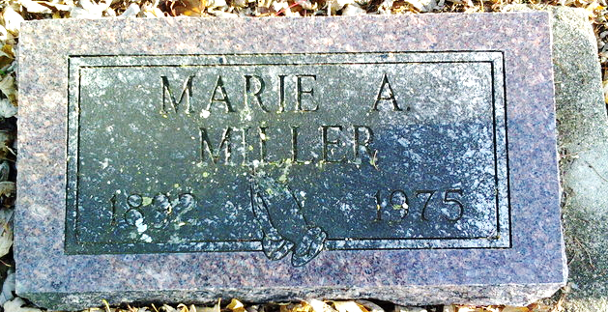
Photo by Thomas Liby

Mrs. Marie A. Miller, 82, of Bluffton, widow of Jens Miller, died at 2 a.m. Friday at Wells community Hospital, where she had been a patient since Dec. 23. Death was attributed to complications from flu.
A daughter of Mont and Sadie Hacket-Harden, she was born Sept. 3, 1892, in Decatur. Her marriage to Jens Miller took place on August 24, 1918, in Bluffton. He died Feb. 3, 1962.
Mrs. Miller, a retired nurse’s aide at Wells Community Hospital, was a member of the Faith Temple at St. Petersburg, Fla.
Surviving are three daughters, Mrs. Herman (Mary Jane) Smeltzer of Bluffton; Mrs. John (Betty) Humphrey of Englewood, Fla.; and Mrs. Gerald (Virginia) Karnes of Muncie; eight grandchildren and two great-grandchildren.
Friends may call after 1 p.m. Saturday at the Thoma-Rich funeral home, where Rev. Calvin Ley will officiate at 3 p.m. services on Sunday. Burial will be in Fairview cemetery.

Decatur Daily Democrat, Adams County, Indiana
Saturday, Jan. 4, 1975
**

Indiana, U.S., Death Certificates, 1899-2017
Name Marie A Miller [Marie A Harden]
Gender Female; Race White
Marital Status Widowed
Age 82
Birth Date 3 Sep 1892; Birth Place Indiana
Death Date 3 Jan 1975; Death Place Bluffton, Wells, Indiana, USA
Father Mont Harden
Mother Saddie Hackett
Informant Mrs. Mary Jane Smeltzer, daughter
Burial Fairview Cemetery 1/5/1975

