Lucy Ann (Fox) Miller
August 10, 1835 – April 24, 1904

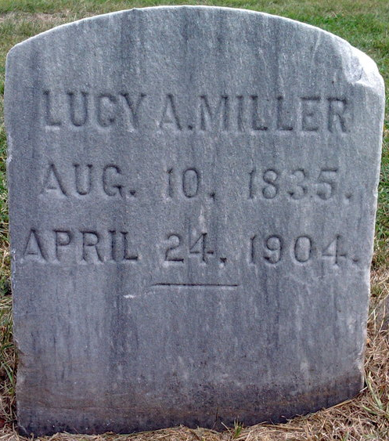
Photo by Thomas Liby

MRS. MILLER DEAD
Another Pioneer Resident Passes Away Sunday Morning After Short Sickness
Mrs. Lucy Ann Miller, one of the pioneer residents of the city of Bluffton, passed away Sunday morning at about 10:30 o'clock at her home in the Arnold Block where she occupied a suite of rooms over the E. M. Hale & Co. jewelry store. She was sick only four days and less than a week ago was able to be on the streets. Last Thursday she was stricken with pneumonia and grew rapidly worse until death relieved her sufferings.
The funeral was held at two o'clock Tuesday afternoon at the M. E. church. Rev. L. A. Beeks conducted the services and burial occurred in Fairview.
Mrs. Miller was a daughter of John and Susan Fox and was born in Virginia on August 10, 1835. When she was five years of age her parents moved to Licking county, Ohio, and in 1853 they moved to Wells county, Indiana, and Mrs. Miller continued to reside here until her death.
The marriage of Miss Lucy A. Fox to Charles Miller occurred on October 13, 1854. When the Civil War broke out in 1861, Mr. Miller enlisted in the Union army and served his Country faithfully until he was mortally wounded at the battle [of] Murphysboro.
Mrs. Miller was married a second time, on May 4, 1865, being wedded to Michael Miller, a brother of her first husband. To this union was born one son, Jefferson Miller, father of John Miller and Mrs. Carrie Cobleigh. He died when the children were small. Michael Miller died in 1898.
Surviving Mrs. Miller in addition to the two grandchildren above named are one brother, John Fox, of Ft. Wayne, and also three step-children. They are Mrs. Mollie Clifton, Mrs. Susan Fisher and William B. Miller, of Marion, who was the first white child born in Bluffton. He was born here on June 4, 1838, being a son of Michael Miller by his first marriage.
Mrs. Lydia Fox, a sister in law of Mrs. Miller, is lying at the point of death at her home on the West Side.
Bluffton Chronicle, Wells County, Indiana
Wednesday, April 27, 1904
Vol. 35, No. 44, p. 1
**

Indiana, U.S., Death Certificates, 1899-2017
Name Lucy Ann Miller
[Lucy Ann Fox]
Gender Female
Race White
Marital Status Widowed
Age 68
Birth Date 10 Aug 1835
Birth Place Virginia
Death Date 24 Apr 1904
Death Place Bluffton, Wells, Indiana, USA
Death Registration Date 1904
Father John Fox
Mother Susan Brown
Informant Carrie Cobley
Burial Fairview 4/26/1904

