John J. Miller
1866 – April 19, 1940

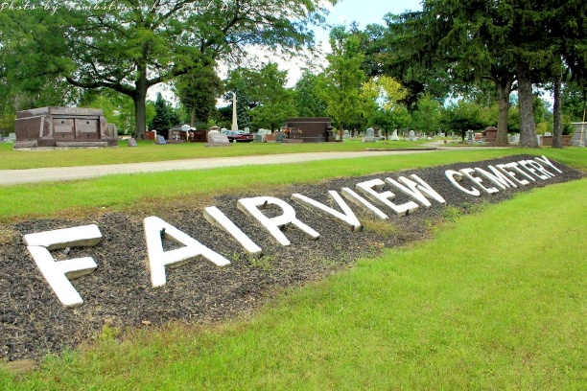
Photo by Tombstoner & Family

MILLER

Bluffton, April 19 – John J. Miller, 70, a former Bluffton resident, died early today at the State Hospital in Richmond, where he had long been a patient.
Surviving are three sons, Homer near Wolcottville, Byron of Fort Swayne and Amos Earl Miller of Nottingham Township and two daughters, Mrs. Hazel Archbold of Tocsin and Mrs. Garnet Kellogg of Fort Wayne.
The body was brought to the funeral home of McBride & Son here. Funeral arrangements have not been completed.

Journal-Gazette, Allen County, Indiana
April 20, 1940
**

Indiana, U.S., Death Certificates, 1899-2011
Name: John J Miller
Gender: Male
Race: White
Age: 70
Marital status: Divorced
Birth Date: 1870
Birth Place: Wells Co
Death Date: 19 Apr 1940
Death Place: Richmond, Wayne, Indiana, USA
Parents: Unknown
Informant: Homer? Fonner; Wolcottville, Indiana
Burial: April 19, 1940 [sic]; Fairview Cemetery; Bluffton, Indiana

