John B. Miller
February 24, 1921 – September 28, 2000

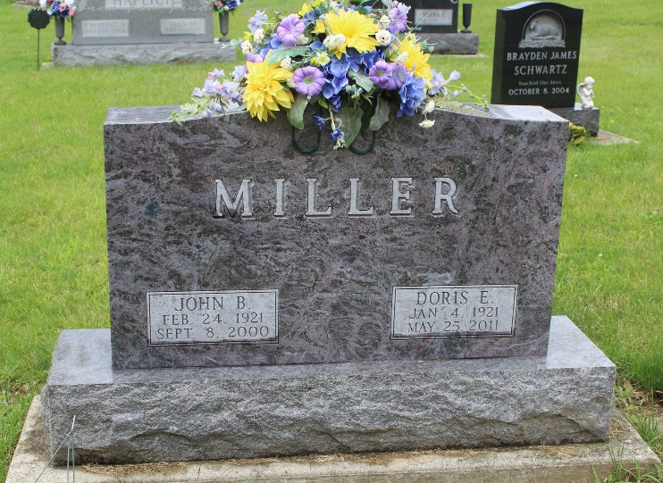
Photo byTombstoner & Family

John B. Miller, a long-time resident of Searcy, Arkansas, died Friday, September 8, 2000. Born February 24, 1921, in Uniondale, Indiana, he was the son of John and Mary Etta Ditzler Miller.
He was a long-time businessman in Searcy, and owned and operated the Miller Milling Company. He was a member of the First United Methodist Church of Searcy and a veteran of World War II. He was a Turret gunner on a bomber that was shot down over eastern Europe.
Survivors include his wife of 57 years, Doris Miller; and sisters, Margaret Cupp and Marceille Shutt of Bluffton, Indiana. He was preceded in death by his parents; and sisters, Lela Haflich, Naomi Boulware, Mary Lou Thomas and Mabeline Keplinger.
Funeral services will be Sunday at 2 p.m. at Powell Chapel in Searcy with burial in Fairview Cemetery in Bluffton, Indiana, by Powell Funeral Home of Searcy. Memorials may be made to the First United Methodist Church in Searcy or CARTI.

Thoma/Rich, Chaney & Lemler Funeral Home, Wells County, Indiana

