Ira J. Miller
February 26, 1900 – June 5, 1940

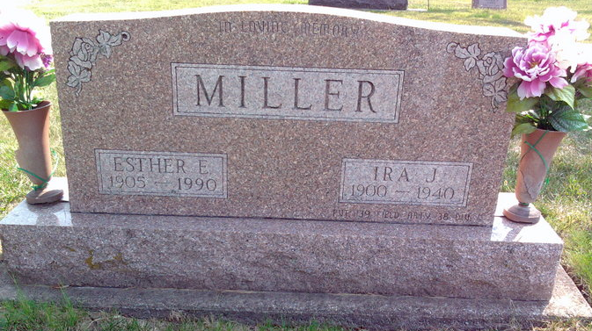
Photo by Thomas Liby

MILLER

Bluffton, June 5 - Ira J. Miller, 40, farmer west of Bluffton, died at 11:30 am today at the county hospital here, following a long illness.
Surviving are the widow; four children, Howard, Norma, Martha and Dale, all at home; a brother, Edwin Miller of Monroeville and a sister, Mrs. Iva Bayless of this city.
Funeral services will be held at 4 pm Friday at the H. Thoma & Son Funeral Home and burial will be in the Fairview Cemetery here.

Fort Wayne Journal-Gazette, Allen County, Indiana
June 6, 1940
**

Indiana, U.S., Death Certificates, 1899-2017
Name Ira J Miller
Gender Male
Race White
Marital Status Married
Age 40y 3m 9d
Military World War
Birth Date 26 Feb 1900
Birth Place Clmondale Indiana
Death Date 5 Jun 1940
Death Place Bluffton, Wells, Indiana, USA
Death Registration Date 1940
Father David Miller
Mother Emma Rabren
Spouse Esther Nidor? Miller, age 35
Informant Mrs. Ira J Miller
Burial 6/7/1940 Fairview
**
Ira Jefferson Miller from tree Ramseyer Family Tree

Birth 26 Feb 1900 Uniondale, Wells, Indiana, USA
Marriage 12 May 1923 Indiana, USA
Residence 1940 Wells, Indiana, USA
Death 5 Jun 1940 Bluffton, Wells, Indiana, USA
Father David H Miller (1854-1935)
Mother Emma Caroline Rhorer (1864-1908)
Spouse Esther Elizabeth Tudor (1905-1990)
8749 People 23 Records 23 Sources

