Esther Elizabeth (Tudor) Miller
May 12, 1905 – October 26, 1990

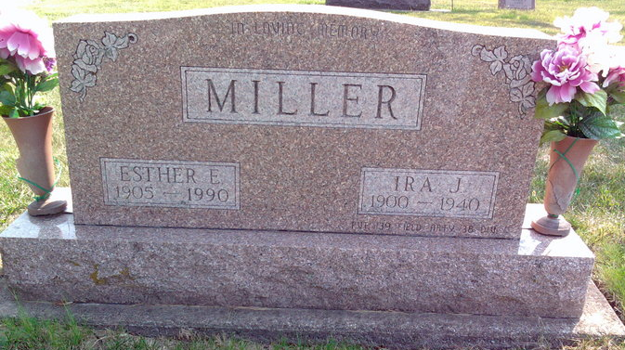
Photo by Thomas Liby

Indiana, U.S., Death Certificates, 1899-2017
Name Esther Elizabeth Miller
Gender Female
Race White
Marital Status Widowed
Age 85
Birth Date 12 May 1905
Birth Place Tipton County, Indiana
Death Date 26 Oct 1990
Death Place Bluffton, Wells, Indiana, USA
Death Registration Date 1990
Father John Tudor
Mother Josephine Goodknight
Informant Howard E. Miller, son
Burial 10/29/1990 Fairview

