Doris E. (Farrell) Miller
January 4, 1921 – May 25, 2011

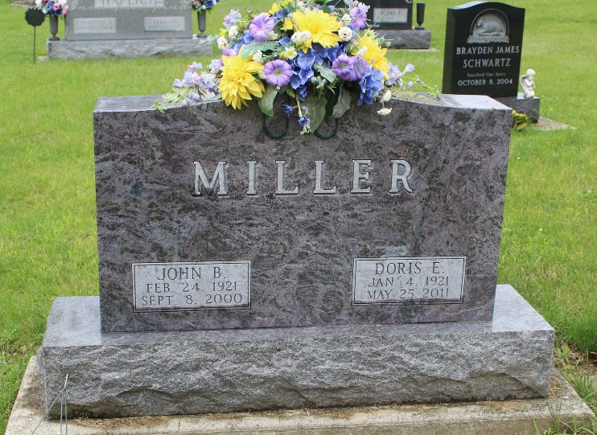
Photo byTombstoner & Family

Doris E. Miller, 90, of Searcy, Arkansas, died Wednesday, May 25, 2011. She is a member of the First United Methodist Church of Searcy. Doris was born January 4, 1921 in Fort Wayne, Indiana, to Earle and Lola Farrell.
She was a lifetime member in the Junior Auxiliary and the Xi Kappa Beta Sigma Phi Sorority, and a member of CARTI and the Searcy Arts council.
She is preceded in death by her husband of 57 years, John B. Miller. She is survived by her sister, Helen Francine "Teenie" Moncrief; her niece Dale Turrentine; a nephew Rick (Karen) Turrentine and family; and a niece Judy Stuckey and family.
Graveside services will be conducted at 11:00 a.m. Saturday, June 4, 2011 at Fairview Cemetery with Pastor Larry Smith officiating. Calling hours will be Saturday from 9:00 a.m. to 10:30 a.m. at Thoma/Rich, Chaney & Lemler Funeral Home. Preferred memorials may be made to the First United Methodist Church of Searcy or to CARTI of Searcy.

Thoma/Rich, Chaney & Lemler Funeral Home, Wells County, Indiana

