David Meyer
January 17, 1872 – April 3, 1940

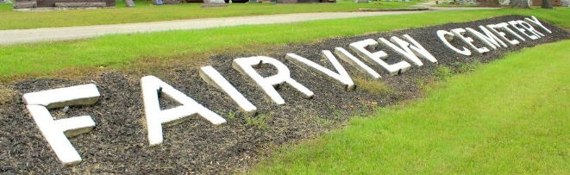
Photo by Tombstoner & Family

DAVID MEYER, 68, MERCHANT, FOUND DEAD AT BLUFFTON

Bluffton, Ind., April 3 – David Meyer, 68, prominent Bluffton business man, was found dead at 11 o’clock tonight in the kitchen of his home here. He physician said that he died of a heart attack.
Mr. Meyer, who had not been in good health, had attended a meeting of dairymen earlier in the evening and his had gone to a Presbyterian Church group meeting. She discovered him when she returned home. He had been dead but a short time, the physician reported.
For more than thirty years, he had operated a harness store here and also owned two dairy farms. He was a member of the county council at the time of his death, having served several terms. He was a member of the Bluffton Elks Lodge and a charter member of the Rotary Club.
Besides the widow, Margaret, he is survived by one son Raymond of Owensboro, Ky.; two sisters, Mrs. John Weinland and Mrs. Louis Baumgartner, both of east of here, and one brother, Jacob of Bluffton. Funeral arrangements have not been completed.

The Star Press, Muncie, Indiana
Thursday, April 4, 1940
**

Bluffton, April 4 - Funeral services for David Meyer, 68, prominent Bluffton business man and county councilman, who died of a heart attack last night at his home here, will be held at the residence at 2 pm Saturday, in charge of Rev. W. J. Lichau, pastor of the First Presbyterian Church. The pallbearers will be past presidents of the Rotary Club, of which Mr. Meyer was a past president.
The body will be placed in the mausoleum at Fairview Cemetery.
William Thoma, president of the Chamber of Commerce, announced that business hours will be closed from 2 to 3 o’clock in tribute to the memory of the deceased, who had been engaged in the harness business here 42 years.

Journal-Gazette, Allen County, Indiana
April 5, 1940
**

One of the most prosperous young business men of Bluffton, Indiana, is David Meyer, a native of Wells county, born in Harrison township, January 17, 1872, and a son of Peter and Elizabeth (Moser) Meyer, of whom a more complete biography will be found on another page of this volume. To Peter Meyer and wife were born eight children, of whom David was the fifth in order of birth. Until seventeen years of age he attended the schools of his district and acquired a good education. After attaining his majority, he went to work on a farm for his brother, Albert, with whom he remained one year, after which he worked a year for his father, and then entered a partnership with Daniel Gilliom in the drilling of wells. This partnership existed until May 25, 1898, when it was dissolved and Mr. Meyer entered a partnership with Jacob Klopfenstine in the harness business at Bluffton, and has probably the best establishment devoted to this line of trade in the city, his business extending throughout the counties of Wells and Adams. Mr. Meyer erected his present brick business block in the fall of 1900 at a cost of five thousand two hundred dollars. It is situated on Main street, is twenty by one hundred and twenty feet in size, and is one of the handsomest business blocks in town.
June 15, 1899, Mr. Meyer was united in marriage with Miss Margaret Engeler, daughter of Frederick and Rosanna (Beberstein) Engeler. Mr. Engeler was a prominent business man of Vera Cruz, Indiana, and a justice of the peace for many years. Mrs. Meyer was born in Vera Cruz, this county, October 22, 1875, and was highly educated in that town. She is a member of the Presbyterian church at Bluffton, is a refined and cultured lady and is highly respected by all who know her.
Mr. Meyer exhibited considerable wisdom when he selected his present line of business as his vocation as his firm has almost an exclusive command of the harness trade over Wells and Adams counties, the only competition, in fact, being through the agents of manufacturing companies that turn out and place upon the market machine-made products, which, all the world knows, are never equal, either in finish, quality or material, to hand-made articles. That Mr. Meyer has made a success in his business is manifest from the high standing he occupies in commercial and trade circles in which his integrity has never been called in question and in which his credit has never been impaired. The social position of Mr. Meyer and wife is the best circles of Bluffton, and both are highly esteemed for their many personal excellences of character. Few young men have attained a more exalted consideration by their fellow citizens than that reached by David Meyer. In his political affiliations he is a Democrat, and he always takes an interest in the success of his party, though he does not aspire to public office.

Biographical Memoirs of Wells County, Indiana; B. F. Bowen Publisher, Logansport, IN, 1903; pg. 577-578.

