Lillian Louisa (Smith) Mettler
February 27, 1903 – April 11, 1975

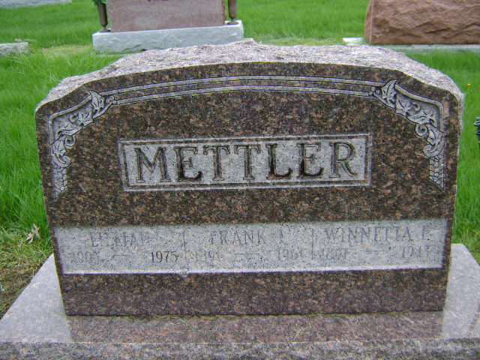

Photo by Bruce Sonner

Funeral services were held Monday at the Thoma-Rich funeral home in Bluffton for Mrs. Lillian Mettler, 72, of Bluffton. She was the sister of Mrs. Doyle (Leona) Clevenger of Decatur. Mrs. Mettler died Friday.
Born in Adams county on Feb. 27, 1903, she was a daughter of William and Elizabeth Smith. Her first marriage was to Roy Diehl and he died in 1937. She later married Frank Mettler, who died in 1961.
Survivors include two daughters, Mrs. Leonard (Louise) Stuff of Bluffton, and Mrs. William (Betty) Edington of Indianapolis; three sisters, Mrs. Doyle (Leona) Clevenger of Decatur; Mrs. Lydia Fulk of Montpelier; Mrs. Jessie Garwood of Ohio; three brothers, Herman Smith of Fort Wayne; Max Smith and Clarence Smith, both of Oklahoma, and three grandchildren.
Burial was in the Six Mile Cemetery.

Decatur Daily Democrat, Adams County, Indiana
Tuesday, April 15, 1975

