Frank J. Mettler
August 16, 1891 – June 21, 1961

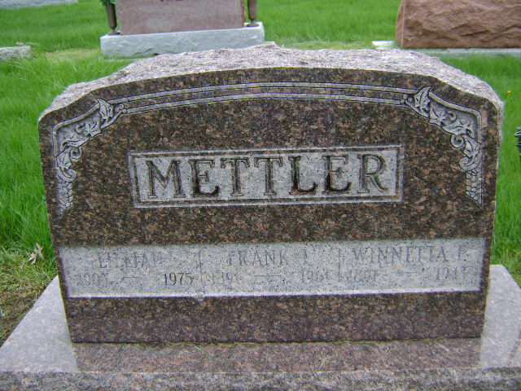

Photo by Bruce Sonner
Attack Is Fatal To Frank Mettler

Frank Mettler, 69, of Bluffton Route 2 died at 5:45 p.m. Wednesday at the Veteran's hospital at Fort Wayne. Death was attributed to a heart attack suffered while eating supper. He had been ill two years.
Born Aug. 16, 1891 in Wells County, Mr. Mettler was the son of Joseph and Ida Flowers Mettler. His marriage to Lillian Deihl, who survives, took place Sept. 27, 1944 in Bluffton.
Employed as a stock buyer and farmer, mr. mettler was a member of the Moose and Elks Lodges and the American Legion Post 111. He was a veteran of World War I and a lifelong resident of Wells County.
Surviving, in addition to the wife, are his mother, Mrs. Ida Mettler, a patient at the Clark Rest home; a son joe of huntington; two step-daughters, Mrs. Leonard Stuff of Bluffton; a sister, mrs. jennie Sowards of Warren, O.,; a brother, Charles (Dovey) of Bluffton, and five grandchildren.
Friends may call after 7 p.m. today at the McBride Funeral home. Services will be conducted at 2 p.m. Saturday at the funeral home with Rev. G. C. Cockrell officiating. Burial will be in the Parkview Cemetery.

Bluffton News-Banner, Wells County, Indiana
Thursday, June 22, 1961, p. 1 col 6
**

Indiana, U.S., Death Certificates, 1899-2017
Name Frank Mettler
Gender Male
Race White
Marital Status Married
Age 69
Military WW I veteran
Birth Date 16 Aug 1891
Birth Place Wells County, Indiana
Death Date 21 Jun 1961
Death Place Fort Wayne, Allen, Indiana, USA
Death Registration Date 1961
Father Joseph Mettler
Mother Ida May Flowers
Informant VA Hospital Records
Burial 6/24/1961 Fairview Cemetery

