Morris M. Messick
February 9, 1919 – May 22, 2004

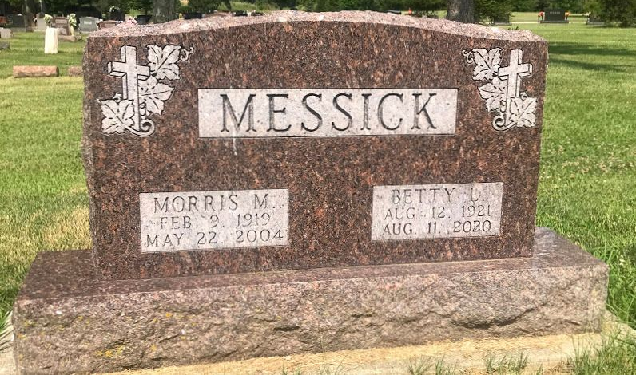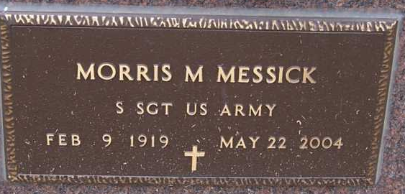
Photo by Pretty Little Grave Seekers

MORRIS M. MESSICK, 85, of Fort Wayne, died Saturday, May 22, 2004, at St. Joseph Hospital, Fort Wayne. Born February 9, 1919, in Wells County, he retired from International Harvester, after 43 years. He was a World War II Army veteran, member of American Legion Post #47 and the Post #47 band, and The Chapel. He enjoyed gardening, fishing, baseball and traveling. “Beloved husband, father, grandfather, who loved his family, church and music.”
Surviving are his wife, Betty Messick of Fort Wayne; sons, Gary (Charlotte) Messick of Roanoke and Dean (Kathy) Messick of Fort Wayne; grandson, Benjamin Messick of New Haven; granddaughter, Susan Lupke of Indianapolis; and great-granddaughter, Hannah Messick of New Haven.
He was preceded in death by his parents, Ernest and Gracie Messick, and a brother, Harold Messick.
Service was Friday, May 28 at The Chapel, 2505 W. Hamilton Road South, Fort Wayne. Visitation was Thursday, May 27 at Elzey Patterson Rodak Home for Funerals, 6810 Old Trail Road. Burial at Fairview Cemetery, Bluffton. Memorials to The Chapel.

Waynedale News, Allen County, Indiana
June 9, 2004

