Elma Elnora (Campbell) Messick
October 24, 1905 – June 19, 2003

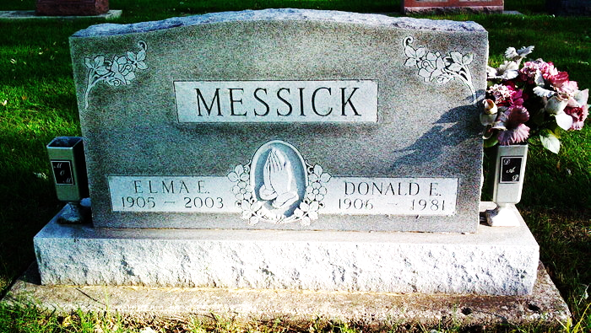
Photo by Thomas Liby

Elma E. Messick, 97, a resident of Meadowvale Health & Rehabili-tation Center in Bluffton, died at 6:20 p.m. Thursday, June 19, at the Bluffton Regional Medical Center. A homemaker, Mrs. Messick was a member of the Epworth United Methodist Church in Bluffton.
She was born in Jay County Oct. 24, 1905, a daughter of James W. and Mary Elizabeth Stoner Campbell. Her marriage in Bluffton on June 22, 1929 was to Donald L. Messick, who died Aug. 9, 1981.
Surviving are a daughter, Mrs. Colleen Hanni of Ossian; a son, Jerry Messick of Kissimmee, Fla.; seven grandchildren; 12 great-grandchild-ren; and four great-great-grandchildren. A son, Richard, and a brother are deceased.
Services at 10:30 a.m. Monday will be at Thoma/Rich, Hewitt & Chaney Funeral Home with Rev. Robert Cahoon officiating. Burial will be in Fairview Cemetery at Bluffton. Calling hours at the funeral chapel will be Sunday from 1 to 8 p.m.
Memorials to the Epworth United Methodist Church.

Bluffton News Banner, Wells County, Indiana
June 20, 2003

