Donald E. Messick
November 18, 1906 – August 9, 1981

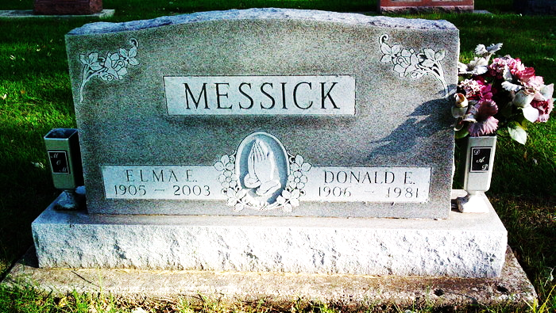
Photo by Thomas Liby

Bluffton, Ind. – Services were conducted here at the Thoma-Rich Funeral Home for Donald E. Messick, 74, who died last Sunday. Retired from the Sterline Casting Co., he was a native of Lancaster Township in Wells County.
Survivors include his wife, Elma C. Campbell Messick, a daughter, Mrs. Kenneth (Colleen) Hann, Tocsin; two sons, Rihcard, Bluffton, and Jerry, Gas City; a brother, Harley Messick, Ada., Ohio; two sisters, Mrs. Gladys Gehrett and Miss Velma Messick, both of Bluffton; 10 grandchildren and four great-grandchildren.

The Muncie Star, Delaware County, Indiana
Saturday, August 22, 1981, p. C1
**

Donald E. Messick
in the Indiana, Death Certificates, 1899-2011
Name: Donald E. Messick
Gender: Male
Race: White
Age: 74
Marital status: Married
Birth Date: 18 Nov 1906
Birth Place: Indiana
Death Date: 9 Aug 1981
Death Place: Bluffton, Wells, Indiana, USA
Father: Charles Messick
Mother: Ethel Mae Mills
Spouse: Elma C. Campbell
Informant: Mrs. Elma Messick; Bluffton, Ind.
Burial: Aug. 12, 1981; Fairview Cem., Bluffton, Ind.

