Betty Louise (Luginbill) Messick
August 12, 1921 – August 11, 2020

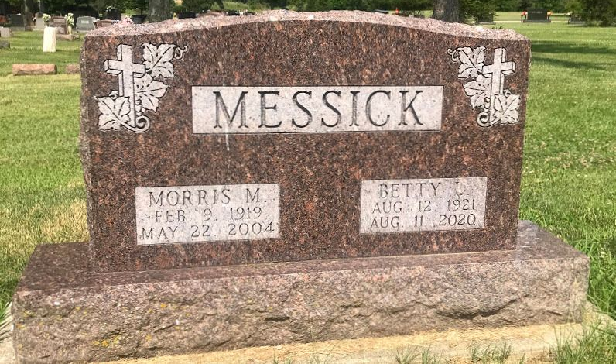
Photo by SMMR

Betty Louise Messick, 98, of Fort Wayne, IN passed away at 8:10am on Tuesday, August 11, 2020 at Covington Commons in Fort Wayne, IN. She was born on Friday, August 12, 1921 in Vera Cruz, IN. She married Morris Messick on Saturday June 29, 1946.
Betty was a 1939 graduate of Lancaster High School. She attended the Chapel in Fort Wayne. She was a homemaker and enjoyed doing crafts and going to hobby shows. She was a member of the Covington Coffee breakfast club that met at Bob Evans in Fort Wayne.
Betty will be sadly missed by her sons-Gary (Charlotte) Messick, Roanoke IN, Dean (Kathy) Messick, Fort Wayne, IN, grandson-Benjamin Messick, Fort Wayne, IN, granddaughter-Susan Lupke, Logansport, IN, and 6 great-grandchildren. She was preceded in death by her father, Joseph Luginbill, mother, Mary (Girod) Luginbill, husband, Morris Messick, and sister, Harriet Sprunger.
Family and friends may gather to share and remember at The Chapel in Fort Wayne on Tuesday, August 18, 2020 from 1pm to 3pm. A service to celebrate her life will be at 3pm at The Chapel in Fort Wayne. Interment will follow in the Fairview Cemetery in Bluffton, IN. Please practice social distancing.
Preferred memorials: The Chapel, 2505 W Hamilton Rd. S, Fort Wayne, IN 46814.
Glancy Funeral Homes, Huntington County, Indiana; Wednesday, August 12, 2020

