Thurman McCullough
1874 – November 10, 1914

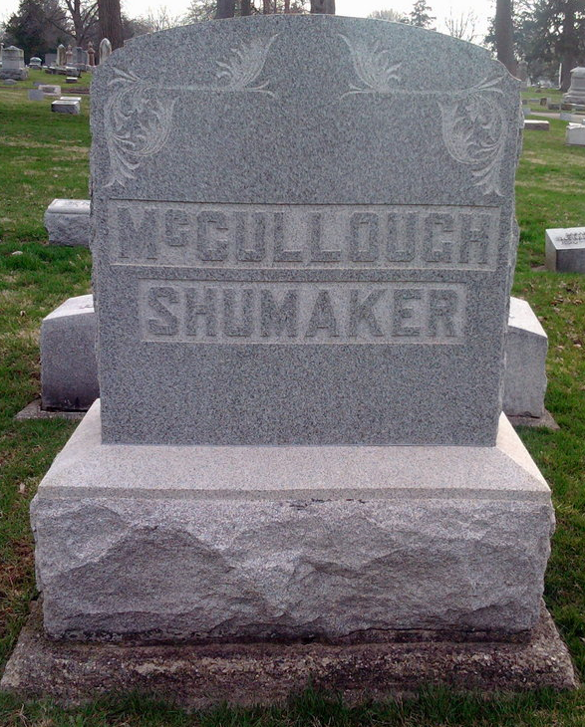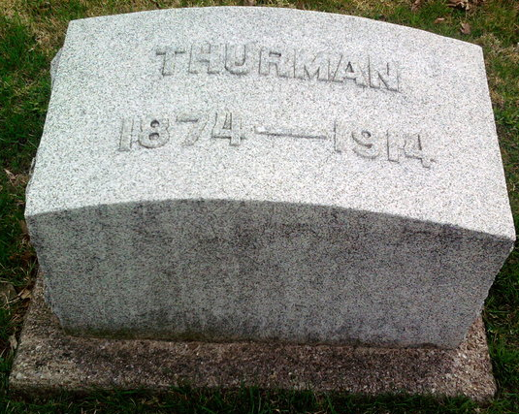
Photo by Thomas Liby

THURMAN McCULLOUGH
(Special to The Daily Courier.)
MIDDLETOWN, Ind., Nov. 13 - Mr. and Mrs. Jacob E. McCullough received a telegram announcing the death of their son, Thurman, at the Santa Fe hospital, Los Angeles, Cal., where he was operated on for appendicitis last Thursday. He was unable to stand the shock of the operation. Mr. McCullough was reared at Markleville and went west four years ago. He paid a visit to his parents here in August.
The body will be shipped to Bluffton for burial.

New Castle Daily Courier, Henry County, Indiana
November 13, 1914
**

California, U.S., Death Index, 1905-1939
Name Thurman L McCullough
Birth Year abt 1874
Death Date 10 Nov 1914
Age at Death 40
Death Place Los Angeles, California, USA

