William P. McConnell
December 28, 1862 – July 9, 1945

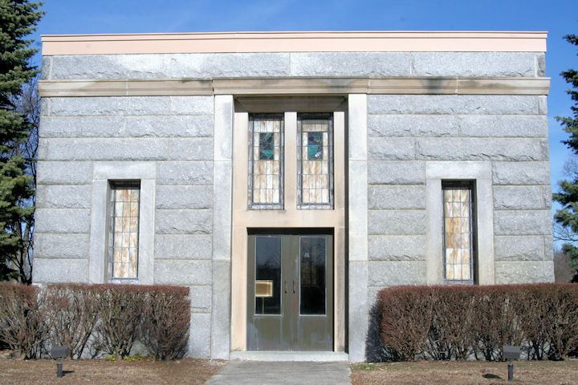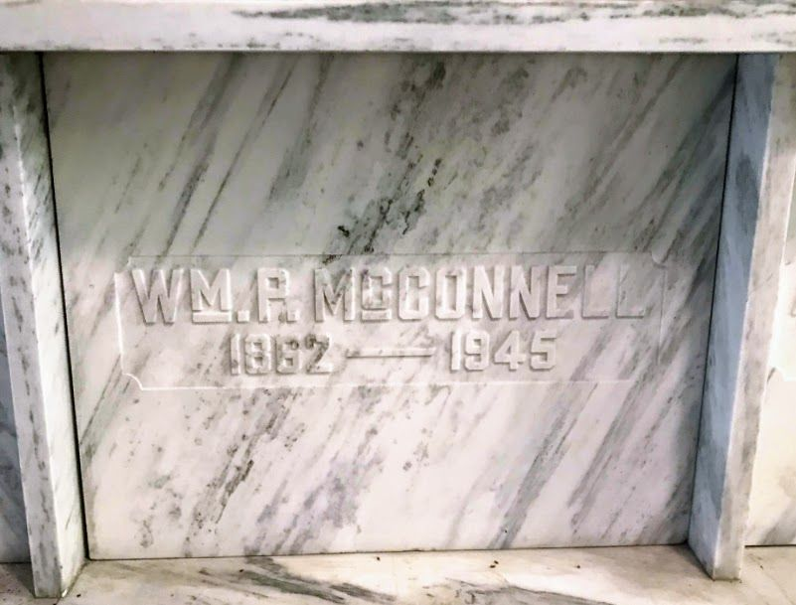
Photos by SMMR

Indiana, U.S., Death Certificates, 1899-2017
Name William P McConnell
Gender Male
Race White
Marital Status Widower
Age 82y 6m 11d
Birth Date 28 Dec 1862
Birth Place Wells County, Indiana
Death Date 9 Jul 1945
Death Place Bluffton, Wells, Indiana, USA
Death Registration Date 1945
Spouse Anna Boden McConnell
Parents unknown
Burial Fairview Cem. 7/14/1945
**
Indiana, U.S., Marriage Certificates, 1960-2012

Name William P McConnell
Gender Male
Marriage License Date 3 Oct 1888
Marriage Date 3 Oct 1888
Marriage Place Wells, Indiana, USA
Spouse Anna M Boden
Parents unknown
Officiator N A Saxton

