Anna Maud (Boden) McConnell
December 31, 1866 – April 5, 1928

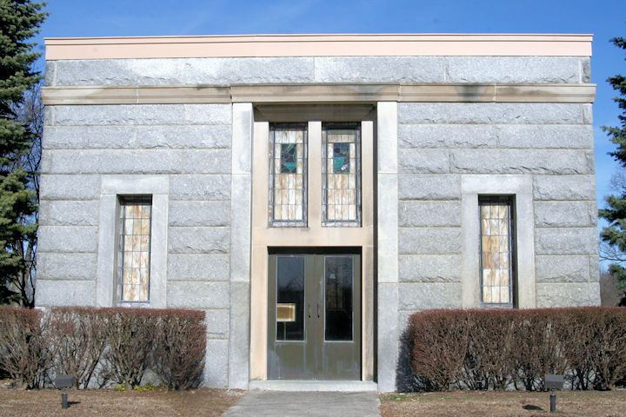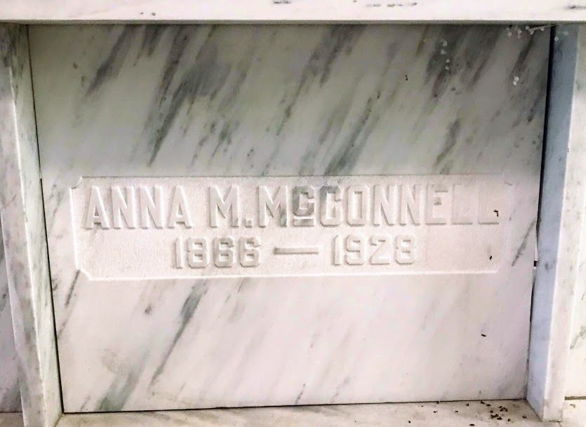
Photos by SMMR

MRS. W. M'CONNELL DIES EARLY TODAY.
DEATH FOLLOWS ILLNESS OF TWO YEARS FROM TUBERCULOSIS.

Mrs. Anna M. Boden McConnell, 61, wife of William P. McConnell, died at her home, 530 East Cherry Street, at 3:40 o'clock this morning following an illness of 2 years suffering from tuberculosis of the bowels. She was a lifelong resident of this county.
She was born in Bluffton, December 3, 1866, the daughter of William and Elizabeth Wort Boden. She was married to William P. McConnell October 3, 1888 at the home of her parents. Surviving besides the husband are one son, George Arden McConnell of Fresno, California.
He and his wife were here visiting at his mother's bedside for 10 days and left last Saturday for their home in California. They will not attend the funeral.
Two brothers, Lewis Boden, of this city; Charles Boden of Francisville, Ind; one half-brother, George E. Stover of this city; two grandchildren, Catherine J. and George Arden McConnell, Jr. also survive.
One son, Van Iry, died at Stockton, Cal in 1918. One sister, Emma Boden Reed also preceded her in death.
The body will lie in state at the McBride parlors, until time for the
services and may be viewed at any time. The funeral will be held at 2:30 o'clock Saturday afternoon at McBride's and burial will be in Fairview cemetery.

Bluffton Evening News, Wells County, Indiana
Unknown date
**

Anna Maud Boden from tree Hoffman Family Tree
Birth 31 Dec 1866 Bluffton, Wells, Indiana, USA
Marriage 3 Oct 1888 Bluffton, Wells, Indiana, USA
Residence 1930 West Portland, Multnomah, Oregon, USA
Death 5 Apr 1928 Bluffton, Wells, Indiana, USA
Father William Boden (1838-1907)
Mother Elizabeth Ann Wertz (1835-1908)
Spouse William P McConnell (1862-1954)
15225 People 7 Records 13 Sources

