William J. McAfee
October 3, 1841 – December 2, 1918

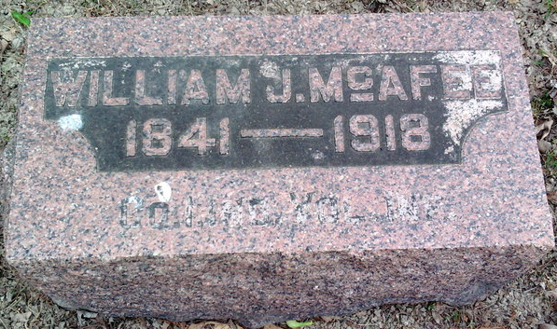
Photo by Thomas Liby

W.J. McAfee Died Suddenly in Detroit
Was Victim of Influenza -- Remains will be brought here for Burial.

Friends and relatives of W. J. McAfee, for years a familiar figure
in Bluffton and Wells County, IN, were saddened this morning by the
announcement of his death, which occurred at six o'clock Monday night at the home of his daughter, Mrs. Bert Tucker, in Detroit, Michigan, at whose home he was visiting. Death was caused by an attack of influenza.
William J. McAfee was born in Wayne County, OH, October 3, 1841, a son of James and Rachel (Dinsmore) McAfee, natives of County Antrim, Ireland. He came with his parents to Wells County, IN when he was 12 years of age, and lived with them here until July 12, 1861, when he enlisted in the United States army, being the first man to enlist in the three years service in Wells County. During his army experience, he saw much active service and was a participant in many of the most important battles of the Civil War, namely: Stone River, Chickamauga, Mission Ridge Atlanta, and the march to the Sea. He also participated in the grand review at Washington at the close of the war and was honorably discharged August 5, 1865. He was wounded twice, in the head at Mission Ridge and in the foot at Kenesaw Mountain.
At the close of the war, he returned to his home in Wells County
and engaged in farming on the old homestead first and later on a farm
which he bought, in Jefferson township. In 1870 he moved to Osage,
Kansas and lived there three years, when he returned to Wells County
and lived on an eighty-acre farm in Lancaster township, later buying
160 acres in Harrison township, and in March, 1885, he moved to
Bluffton, where he was engaged in business for a number of years. In
the later years of his active life he was a mail carrier on one of the
rural routes out of Bluffton for many years.
Mr. McAfee was married on September 27, 1867 to Mary E. Taylor, a
native of Trumbull County, OH, who passed away many years ago. He was married a second time on June 12, 1889 to Mrs. Laura Johnson at Warsaw, IN, who also preceded him to death several years ago.
The following children survive to mourn a kind and loving father: Harry and Ellsworth McAfee of Fort Wayne, IN, James McAfee of Indianapolis, IN, Mrs. Bert Tucker of Detroit, MI, and Mrs. John Shoemaker. There are also two (three?) stepchildren, Mrs. Earl Myers of Portland, Oregon, Guy Johnson of Fitzgerald, GA, and Mrs. George Goodspeed of Bluffton, IN. One sister also survives him, Mrs. Mary McAfee of Murray, and one sister and one brother, Mrs. James Earl and Sam McAfee, preceded him in death.
Mr. and Mrs. McAfee also took into their home two grandchildren,
Mrs. Arthur Lowe, of Farmington, Washington, and Mrs. Clinton Rice of Lawton, Oklahoma, and raised them from early childhood.
Mr. McAfee was a member of the Presbyterian church of this city
and was also a prominent member of Lew Daily Post G. A. R. He was for a number of years commander of the post.
The body will be brought to Bluffton, IN from Detroit, MI Thursday
morning and taken to McBride's undertaking parlors. Complete funeral arrangements have not yet been made, but the services will be conducted by the Rev. D. C. Truesdale, pastor of the Presbyterian church. Internment will be in Fairview.

Unknown source

