Laura Minerva (Funk) McAfee
February 17, 1849 – February 17, 1918

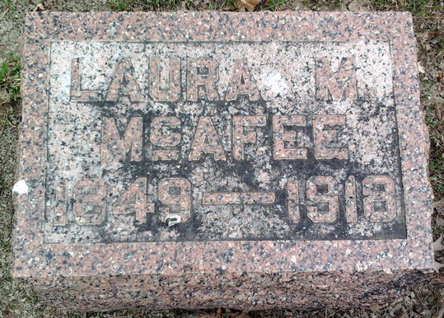
Photo by Thomas Liby

BLUFFTON WOMAN DIES AT PIERCETON

BLUFFTON, IND., Feb 18 – Mrs. William J. McAfee, sixty-four, wife of a well known Bluffton Grand Army man, is dead at Pierceton, where she had been visiting with a niece. Her death was due to pneumonia and followed a week’s illness.
The remains will be returned to Bluffton tomorrow and will be taken to the home of a daughter, Mrs. George Goodspeed.
Mrs. McAfee’s maiden name was Laura Funk. Her first marriage was to Samuel Johnstone (sic) and three children survive, namely, Mrs. George Goodspeed, Mrs. Earl Myers, of Vancouver, Wash., and Guy Johnstone of Fitzergerald, Ga. There are also eleven grandchildren.

Fort Wayne Journal Gazette, Allen County, Indiana
Tuesday, February 19, 1918
**

Indiana, U.S., Death Certificates, 1899-2017
Name Lora M McAfee
Gender Female
Race White
Marital Status Married
Age 69
Birth Date 17 Feb 1918 (sic)
Birth Place Ohio
Death Date 17 Feb 1918
Death Place Washington, Kosciusko, Indiana, USA
Death Registration Date 1918
Father Henry Finck
Mother Amanda Corion
Spouse Wm J McAfee, informant
Burial Bluffton, Ind. 2/21/1918
**
Laura Minerva Funk from tree Owens Family Tree
Birth 20 Feb 1849 Urbana, Champaign, Ohio, USA
Marriage 12 Jun 1889 Kosciusko, Indiana, USA
Residence 1910 Bluffton, Wells, Indiana, USA
Death 17 Feb 1918 Bluffton, Wells, Indiana, USA
Father Henry Funk (1810-1905)
Mother Amanda Araminta Sarah Lettice Corwin (1818-1895)
Spouse William J McAfee (Born 1858)
1438 People 16 Records 20 Sources

