Leslie “Chopper” Mazelin
October 8, 1951 – September 10, 2018

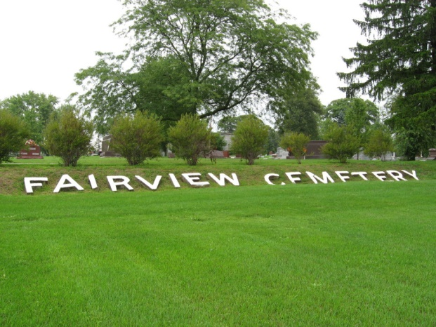
Photo by Tombstoner & Family

Leslie L. “Chopper” Mazelin, 66, of Bluffton passed away on Monday morning, September 10, 2018, at Bluffton Regional Medical Center. He was born on October 8, 1951 in Bluffton to Siles Mazelin & Viola (Andrews) Staples. Chopper attended Southern Wells High School and was an active member of River of Life Church in Bluffton and attended Bluffton Church of God. He was a gentle giant, who loved sharing his faith and talents with others. He loved to sing the old traditional hymns both at church and with the residents of care facilities. He enjoyed spending time outdoors and fishing. On December 26, 1987 in Poneto, Chopper and Debbie A. (Deininger) were married.
He is survived by his wife Debbie of Bluffton along with his siblings; Debbie (Bill) Lowe of Marion, Elaine (Charlie) Sills of Bluffton, Kristi (David) Davis of Georgia, Roxanne (Larry) Doublin of Geneva, Rochelle (Gary) Jamison of Bluffton, Joey (Doug) Pierce of Montpelier, Carla Staples of Poneto, Dana Staples and Gary Hays, both of Florida. He will also be remembered by many nieces and nephews.
Chopper is preceded in death by his parents, a sister Gloria Keller and a brother, Dennie Mazelin.
A service to celebrate Chopper’s life will be held at 4 P.M. on Thursday (September 13, 2018) at the Bluffton Church of God. Pastor John Roe & Pastor Wayne Ball will officiate. Friends are encouraged to visit with the family from 2 P.M. to 4 P.M. on Thursday, prior to the service. Burial will take place at Fairview Cemetery in Bluffton.
Memorials may be made to the family through the funeral home.
Thoma/Rich, Lemler Funeral Home, Wells County, Indiana
September 11, 2018

