Audrey M. Matson
September 29, 1912 – January 20, 2007

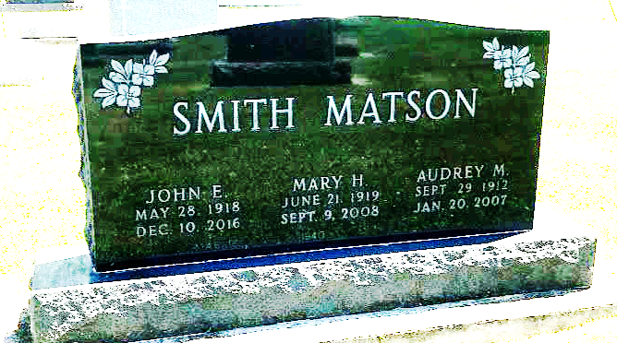
Photo by SMMR

Audrey M. Matson, 94, of Bluffton died at 4:40 p.m. on Saturday, Jan. 20, 2007 at Meadowvale Health & Rehabilitation Center.
She had worked as a clerk in the Social Security office in South Bend for 28 years until her retirement in 1987. She had also worked for nine years at the Kingsbury Ordinance Plant in LaPorte, Ind., for 9 years. Audrey was a committed volunteer at the Wells Community Hospital Gift Shop, The Bargain Hut, West Haven Nursing Home, and the Red Cross. She had resided in LaPorte and South Bend for 37 years and returned to Wells County in 1987.
She was born in Ferriday, La., on Sept. 29, 1912, a daughter of Frank and Jessie (Carlson) Matson. She was a 1930 graduate of Bluffton High School (P.A. Allen). She was a member of Mulberry Wesleyan Church.
She is survived by her sisters Mary (John) Smith of Bluffton and Dorothy (Paul) Gerwig of Bluffton, along with several nieces and nephews.
She was preceded in death by her sisters Marguerite Cash and Eva Shepherd.
Calling will be Thursday from 2 to 8 p.m. at Thoma/Rich Hewitt and Chaney Funeral Home. Services will be held at 10:30 a.m. on Friday at the funeral home, with Rev. Don Hosier officiating. Burial will be in Fairview Cemetery. Preferred memorials are to the Mulberry Wesleyan Church.

Bluffton News-Banner, Wells County, Indiana
Monday, January 22, 2007

