Marquis Lafayette Marquart
October 3, 1842 – December 3, 1917

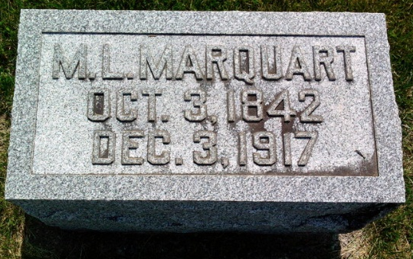
Photo by Thomas Liby

WAR VETERAN DIES
Final Illness Proves Fatal To Pioneer Resident

BLUFFTON, Ind., Dec. 3 - Marquis L. Marquardt, 73, a pioneer resident and civil war veteran passed away at an early hour Monday morning, after an illness of several months, due to the infirmities of old age and complications due to wounds received in the war. Death was expected and his family was at his bedside when the angel of death came to claim his soul.
The veteran fought through four years of the rebellion, enlisting in Fort Wayne. He marched with Sherman to the sea and was with Grant at the surrender. He had been a popular member and leader of the G.A.R. for a number of years.
Surviving are the widow and three children, William Marquardt, Mrs. Etta Heller of Bluffton, and Mrs. M. O. Patrey, of Milwaukee. A number of friends and relatives survive in Adams and Allen counties.

Fort Wayne Sentinel, Allen County, Indiana
December 5, 1917
**

Indiana, U.S., Death Certificates, 1899-2017
Name Marguis Lafayette Marquart
Gender Male; Race White
Marital Status Married
Age 76y 2m
Birth Date 3 Oct 1840 [3 Oct 1842]
Birth Place Allen County, Indiana
Death Date 3 Dec 1917
Death Place Bluffton, Wells, Indiana, USA
Father Jonathan Marquart
Mother Catherine Bashore
Spouse Catherine Clear Marquart
Informant Well Marquart, Bluffton, IN
Burial Fairview Cem. 12/5/1917

