Catherine (Clear) Marquart
April 5, 1844 – September 29, 1923

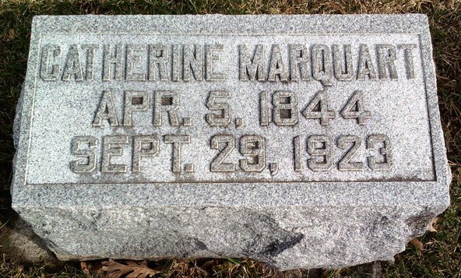
Photo by Thomas Liby

Catherine Clear Margaret
in the Indiana, U.S., Death Certificates, 1899-2017
Name: Catherine Clear Marquart
[Catherine Clear]
Gender: Female
Race: White
Age: 79
Marital status: Widow
Birth Date: 5 Apr 1844
Birth Place: Allen Co Indiana
Death Date: 29 Sep 1923
Death Place: Bluffton, Wells, Indiana, USA
Death Registration Date: 1923
Father: Henry Clear
Mother: Sarah Sunnington ??
Spouse: Marquis Marquart
Informant: W. H. Marquart; Bluffton, Indiana
Burial: October 1, 1923; Fairview Cemetery

