Edna H. (Johnson) Mapes
August 5, 1906 – January 3, 1988

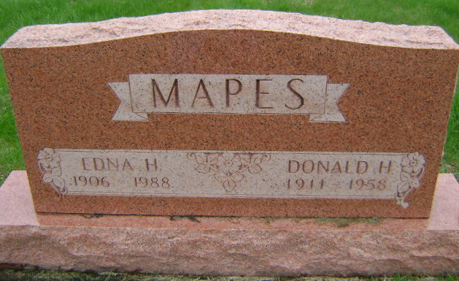
Photo by Bruce Sonner

Edna H. Mapes, 81, Bluffton, sister of Mrs. Arellia Helmrich, route 2, Decatur, died at 9:20 a.m. Sunday in Wells Community Hospital, Bluffton.
She retired in 1970 from General Electric Co. in Fort Wayne after 29 years of service.
Her husband, Donald, died in 1958. Survivors include two sons, Francis Holmes and Duane Holmes, both of Bluffton; two other sisters; one brother; and 14 grandchildren.
Services will be held at 10:30 a.m. Wednesday in Thoma-Rich Funeral Home, Bluffton, where friends may call from 2-5 and 7-9 p.m. today. Memorials are to the Heart Fund.

Decatur Daily Democrat; Adams County, Indiana
Tuesday, January 5, 1988
**

Indiana, U.S., Death Certificates, 1899-2011
Name: Edna H Mapes
[Edna H Johnson]
Gender: Female
Race: White
Age: 81
Marital status: Widowed
Birth Date: 5 Aug 1906
Birth Place: Bluffton, Indiana
Death Date: 3 Jan 1988
Death Place: Bluffton, Wells, Indiana, USA
Father: Emmitt Johnson
Mother: Gladys Workman
Informant: Duane Holmes; son; Bluffton, Indiana
Burial: January 6, 1988; Fairview Cemetery; Bluffton, Indiana

