Donald Henry Mapes
July 28, 1911 – April 20, 1958

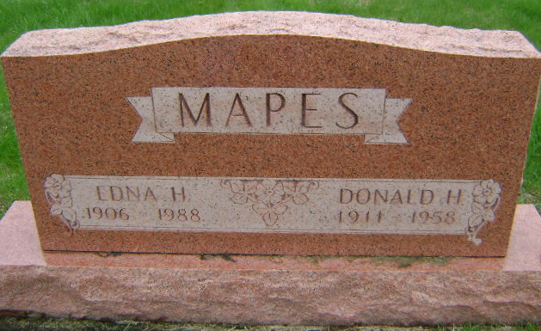
Photo by Bruce Sonner

Indiana, U.S., Death Certificates, 1899-2017

Name Donald H. Mapes
Gender Male
Race White
Marital Status Married
Age 46
Birth Date 1911
Birth Place Indiana
Death Date 20 Apr 1958
Death Place Bluffton, Wells, Indiana, USA
Death Registration Date 1958
Father Leroy Mapes
Mother Clara Houser
Informant Edna Mapes, wife
Burial 4/22/1958 Fairview Cemetery
**
U.S., World War II Draft Cards Young Men, 1940-1947
Name Donald Henry Mapes
Gender Male; Race White; Age 29
Relationship to Draftee Self (Head)
Birth Date 28 Jul 1911
Birth Place Huntington, Indiana
Residence Place Bluffton, Wells, Indiana, USA
Registration Date 16 Oct 1940
Registration Place Indiana, USA
Employer Putnam and Greene Cons Co
Height 6; Weight 230
Complexion Light; Hair Color Brown; Eye Color Brown
Next of Kin Leroy Mapes

