Rosalie E. (Ashbaucher) Liechty
September 8, 1867 – February 8, 1941

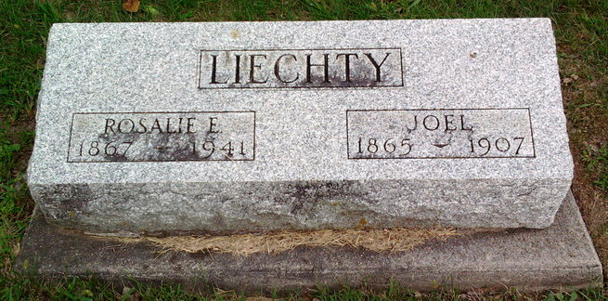
Photo by Thomas Liby

ROSALIE LIECHTY FUNERAL TODAY
WIDOW OF JOEL LIECHTY WHO HAS RELATIVES HERE
DIES AT BLUFFTON

Mrs. Rosalie Liechty, 73, widow of Joel Liechty, died at 5:30 a.m. Saturday at the home of her daughter, Mrs. Omer Stout, following an illness of one year of carcinoma.
Mrs. Liechty was born Sept. 8, 1867 in Wells county, a daughter of Christian and Malena Arnold Ashbaucher. Her marriage March 14, 1889 was to Joel Liechty, who died Nov. 27, 1907.
Surviving are five daughters, Mrs. Myrl Stout, of Bluffton; Mrs. Earl Markley, near Bluffton; Mrs. Justine O. Veit, of Dearborn, Mich., and Mrs. Clayton G. Kagy and Mrs. William R. Younger, of Warren, O.; three sisters, Mrs. Mary Ann Klopfenstine, of Bluffton, Mrs. J. C. Augsburger and Mrs. Jeff Augsburger, near Berne, and two brothers, A. D. Ashbaucher, of Bluffton, and O. H. Ashbaucher, of Toledo, O. A brother and a sister are deceased.
Funeral services were held at 2:30 p.m. today at the Evangelical and Reformed church, of which Mrs. Liechty was a member, in charge of Rev. Matthew Worthman. Burial was made in the Fairview cemetery.

Adams County (IN) Historical Museum
1941a Jan-June Scrapbook, image 010-011
Handwritten-Mon. Feb. 10, 1941

