Joel Liechty
January 11, 1865 – November 28, 1907

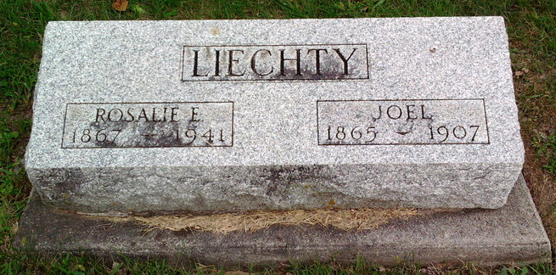
Photo by Thomas Liby

Joel Leichty
in the Indiana, U.S., Death Certificates, 1899-2011
Name: Joel Liechty
Gender: Male
Race: White
Age: 42
Marital status: Married
Birth Date: 11 Jan 1865
Birth Place: Adams Co Ind
Death Date: 28 Nov 1907
Death Place: Bluffton, Wells, Indiana, USA
Father: Jacob Liechty
Mother: May Tschume
Spouse: Rosalie
Informant: Mrs. J. Liechty; Bluffton, Indiana
Burial: December 2, 1907; Fairview Cemetery

