- Elizabeth (Moser) Lesh
January 26, 1880 – May 5, 1968

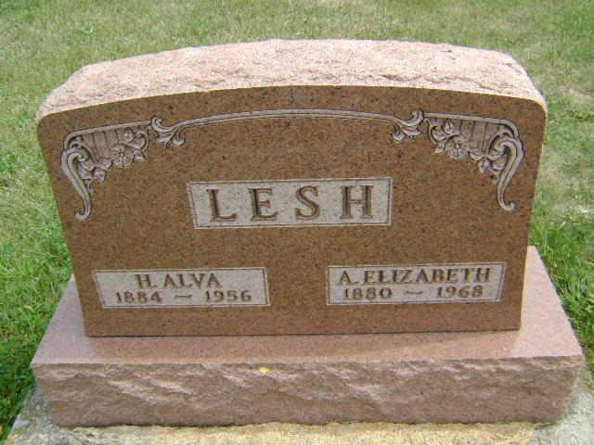
Photo by Bruce Sonner

Indiana, U.S., Death Certificates, 1899-2017
Name Elizabeth Anna Lesh
[Elizabeth Anna Moser]
Gender Female
Race White
Marital Status Widowed
Age 88
Birth Date 26 Jan 1880
Birth Place Indiana
Death Date 5 May 1968
Death Place Bluffton, Wells, Indiana, USA
Death Registration Date 1968
Father Benedict Moser
Mother Elizabeth Gering
Informant Mrs. Mary Stuff, sister
Burial St. Paul Cemetery, Wells County, IN 5-7-1968

