James Weber Lawrence
1897 – July 17, 1932

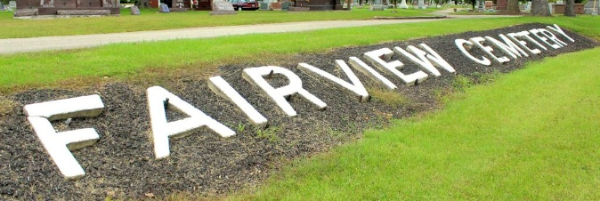
Photo by Tombstoner & Family

LAWRENCE

Bluffton, June 17 – James Weber Lawrence, 36, 1118 Hamilton Avenue, Fort Wayne, died at the Wells County Hospital in this city at 8 o’clock this morning. He had been at the hospital since Monday for observation for diabetes. He was a foreman in the toolmaking department of the International Harvester Company, Fort Wayne.
Surviving are the widow, the grandparents, Mr. and Mrs. Z. T. Webber, Bluffton; an aunt, Mrs. Fred Ardner and an uncle, Harry Webber, Bluffton.
The body was taken this evening to the home in Fort Wayne and funeral services will be held at the home Monday afternoon. The body will be placed in the Fairview Mausoleum near Bluffton.

Journal-Gazette, Allen County, Indiana
June 18, 1932, Page 3
**

Indiana, U.S., Death Certificates, 1899-2017
Name James Lawrence
Gender Male
Race White
Marital Status Married
Age 34y 9m 13d
Birth Date 4 Sep 1898
Birth Place Indiana
Death Date 17 Jun 1932
Death Place Bluffton, Wells, Indiana, USA
Death Registration Date 1932
Father Michael Lawrence
Mother Luddie Webber
Spouse Cora Lawrence, informant
Burial Fairview Cem, Bluffton 6/20/1932
**
Indiana, U.S., Marriage Certificates, 1960-2012
Name James Webber Lawrence
Marriage Age 28
Birth Date 4 Sep 1897
Marriage Date 10 Jul 1926
Marriage Place Grant, Indiana, USA
Father Walter Lawrence
Mother Luddie Webber
Spouse Cora Pauline Antrim
Certifier S A Connelly
Officiator John E Flemming
Certificate Number 15306

