Cora Pauline (Ross) Lawrence
May 28, 1903 – September 14, 1999

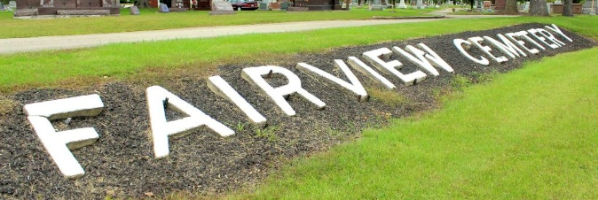
Photo by Tombstoner & Family

Indiana, U.S., Death Certificates, 1899-2017
Name Cora Pauline Lawrence
[Cora Pauline Ross]
Gender Female
Race Caucasian (White)
Marital Status Widowed
Age 96
Birth Date 28 May 1903
Birth Place Sweetser, Indiana
Death Date 14 Sep 1999
Death Place Bluffton, Wells, Indiana, USA
Death Registration Date 1999
Father Mahlon Ross
Mother Nancy A. Foster
Informant Nancy New, niece
Burial 9/16/1999 Fairview Cemetery
**
Indiana, U.S., Marriage Certificates, 1960-2012
Name James Webber Lawrence
Marriage Age 28
Birth Date 4 Sep 1897
Marriage Date 10 Jul 1926
Marriage Place Grant, Indiana, USA
Father Walter Lawrence
Mother Luddie Webber
Spouse Cora Pauline Antrim
Certifier S A Connelly
Officiator John E Flemming
Certificate Number 15306

