Orva Carl Lantis
April 27, 1883 – Apr 30, 1935

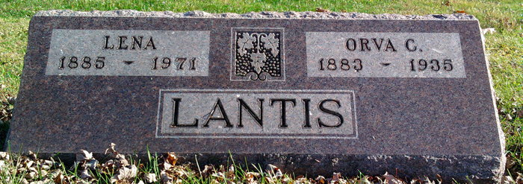
Photo by Thomas Liby

SHERIFF DIES

Funeral services are to be held in the First Bluffton M. E. Church at 2:30 p.m. Wednesday for Orv. C. Lantis, Sheriff of Wells County, who died at his home Monday.

Adams County (IN) Historical Museum
1935 Scrapbook, image 17
Handwritten: Tuesday, April 30
**
Indiana, U.S., Death Certificates, 1899-2017
Name Orva Carl Santis
Gender Male
Race White
Marital Status Married
Age 52y 0m 3d
Birth Date 27 Apr 1883
Birth Place Harrington Co, Indiana
Death Date 29 Apr 1935
Death Place Bluffton, Wells, Indiana, USA
Death Registration Date 1935
Father Jacob Lantis
Mother Emaline Redding
Spouse Lena Harshman Lantis
**
Indiana, U.S., Marriages, 1810-2001
Name Orva C Lantis
Gender Male
Event Type Marriage Registration (Marriage)
Marriage Date 23 Feb 1905
Marriage Place Indiana, United States
Spouse Lena Harshman
Page 395
FHL Film Number 002318464

