Lena (Harshman) Lantis
September 12, 1885 – November 19, 1971

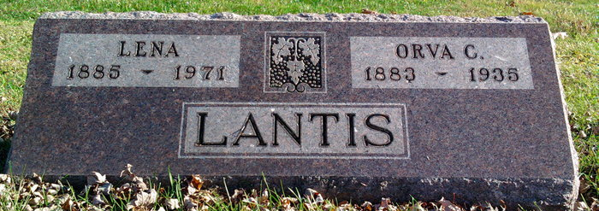
Photo by Thomas Liby

Entered Into Eternal Rest Friday, Nov 19, 1974
Mrs. Orva C Lantis
Funeral service for Mrs. Lena Harshman Lantis, 86, of 310 Warwick Lane, will be conducted Monday afternoon in Bluffton, Ind. The widow of Orva C Lantis, she died Friday at her home. Born in Uniondale, Ind., she was a daughter of John Edgar Harshman and Isabelle Gorman Harshman. She was a member of Storrs United Church of Christ, Storrs, Conn.
She is survived by two daughters, Mrs. George McReynolds of Lynchburg and Aldine Lantis of Ovid, Mich.; four sons, Clarence Lantis of Bethel, Del., Jerald Lantis of Jonesville, Mich., Grenvere Lantis of Owosso, Mich., and Gale Lantis of Lyndhurst; a sister, Mrs. E. J. Miller of Fort Wayne, Ind., and six grandchildren.

The News, Lynchburg, Virginia
Unknown date

