Lydia Rebecca (Hey) LaTurner
June 26, 1860 – July 13, 1942

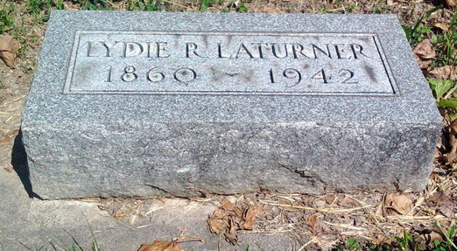
Photo by Thomas Liby

Lydia LATURNER, 82, Answers Summons
Death Occurs This Morning At Home Here
Funeral Wednesday P. M.-

Mrs. Lydia Rebecca LATURNER, 82, lifelong resident of Wells county, died at 7:30 a.m. today at her home at 217 1/2 West Market street. Death was due to complications following an illness of eight weeks.
Born June 26, 1860, the decedent was the daughter of Joel and Rebecca BENDER HEY. She was married in Bluffton March 25, 1880 to Franklin LATURNER, whose death occurred Feb. 7, 1935.
Surviving are three sons, Roscoe LATURNER, near Monroe, William LATURNER, of Bluffton, and Orval LATURNER of LaSalle, Mich.; a daughter Mrs. Goldie BRANT, of Monroe, Mich., 25 grandchildren; 44 great-grandchildren; four great-great grandchildren, and a sister, Christena CLARK, who resided with her sister. Four children, four sisters and five brothers are deceased.
Mrs. LaTurner was a member of the Methodist church.
Funeral services will be held at 2 p. m. Wednesday at the Jahn funeral home in charge of Rev. Edward Smith. Burial will be in the Fairview cemetery.

Evening News-Banner, Wells County, Indiana
13 Jul 1942

