Franklin Jesse LaTurner
January 18, 1852 – February 7, 1935

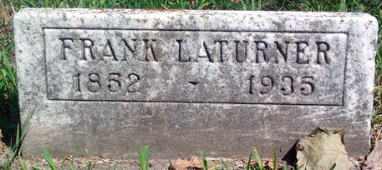
Photo by Thomas Liby

Franklin LATURNER Claimed By Death
Death Follows Illness of Six Weeks; Funeral Services Sunday

Franklin LATURNER, 83, died at 6:15 Thursday Evening at his home, 718 West Miley Avenue, from an illness of six weeks from heart trouble and other infirmities.
He was born in Wells county on Jan. 13, 1852, to Henry and Nancy WILCOX LATURNER and was a lifelong resident of the county. His marriage to Lydia HEY was solemnized in Bluffton on March 25, 1880.
Surviving are the widow; two daughters, Mrs. Nora BRENNER, and Mrs. Goldie BRANT, Monroe, Mich.; three sons, Ross LATURNER, Decatur and William and Orville LATURNER, Monroe, Mich.; one half-brother, Lee LATURNER, Markle; 21 grandchildren and 19 great grandchildren. Three daughters preceded him in death.
Funeral services will be held at 2 o'clock Sunday afternoon at the First Christian church, of which he was a member. Burial will be in the Fairview cemetery.

Evening News-Banner, Wells County, Indiana
Friday, 8 Feb 1935, p. 1

