Minnie Aubrey (Morgan) Kunkel
December 17, 1871 – March 10, 1929

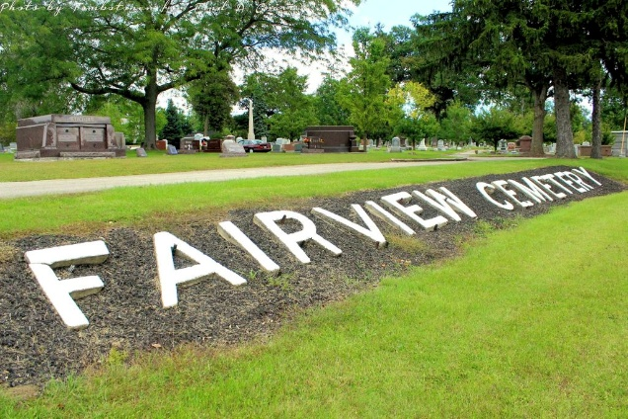
Photo by Tombstoner & Family

MRS. WILLIAM A. KUNKEL, SR., DIES SUNDAY
ESTEEMED LOCAL LADY PASSES AWAY AT HOME IN THIS CITY.
Mrs. Minnie A. Morgan Kunkel, 57, prominent and respected Bluffton lady, wife of William A. Kunkel, Sr., passed away at 9 a. m. Sunday at her home at 328 South Oak street following an illness of about three years of cancer.
Mrs. Kunkel was held in high esteem by all who knew her and her passing brings sorrow to everyone. While her illness was known to be of a serious nature from the state, she was given every care known to medical science. She was taken to St. Louis for treatment by Dr. E. C. Ernst, a specialist, and also to Cleveland, Ohio, where she was under the care of another famous specialist, Dr. Crile. For a time her condition seemed to improve, but on Dec. 12, 1928, she was brought home, all efforts to help her apparently having failed.
She was kept under the care of a trained nurse at her home and up until two weeks before her death, she retained her usual pleasant disposition and interest in her family and friends. The last two weeks, her resistance slowly ebbed until death came to relieve her suffering.
Minnie Aubrey Morgan Kunkel was born at Majenica, Huntington county, on Dec. 17, 1871, a daughter of John V. and Mary A. Morgan. She was an only child. When she was four years of age, her parents brought her to Bluffton, residing in a home that stood on the site of the present Kunkel residence on South Oak street. Her father was the contractor who built the old city building here at the corner of Johnson and Washington streets. Mr. Morgan passed away in 1885 and Mrs. Morgan passed away in 1916.
Mrs. Kunkel graduated from the Bluffton high school with the class of 1886 at the age of 14. While still only 14 years of age she taught school. She later went to Huntington and taught in the city schools there until in June, 1981.
On June 24, 1891, she was united in marriage to William A. Kunkel, Sr., who was at that time surveyor for Wells county.
Surviving besides the husband are three children: William A. Kunkel, Jr., Kenneth M. Kunkel and Marjorie Kunkel Brown, all of this city. There are three grand-children surviving; Mary Ann Kunkel, William A. Kunkel, III, and Harriett Kunkel Brown.
Prior to her last illness, Mrs. Kunkel was an active worker in the Methodist Episcopal church. She was a member of Mrs. Martin's Sunday school class. Mrs. Kunkel was also the first secretary of the Women's Federated clubs when organized here. Mrs. W. W. Mason was the first president.
Mrs. Kunkel was of a pleasant and friendly disposition that won friends for her wherever she went. Outside of the confidence and respect held by friends, the greatest tribute to be paid her is that she was a wonderful wife and mother.
Mr. Kunkel in speaking of her said he attributed every success he had made in life to her. For months, when Mr. Kunkel was struggling to make a good business, and at times when he was called away to look after his interests in the oil fields in other states, it was Mrs. Kunkel who shouldered the burden of looking after the family and keeping the home in order. That she succeeded nobly is evidence by her splendid family.
Funeral services will be held at the home on South Oak street at 2 p.m. Tuesday in charge of Rev. W. W. Martin. Burial will be at the family lot in Fairview cemetery.

Evening Banner, Bluffton, Wells County, Indiana
Monday, March 11, 1929, P 1, C 3

