John O. Kunkel
December 23, 1852 – March 23, 1940

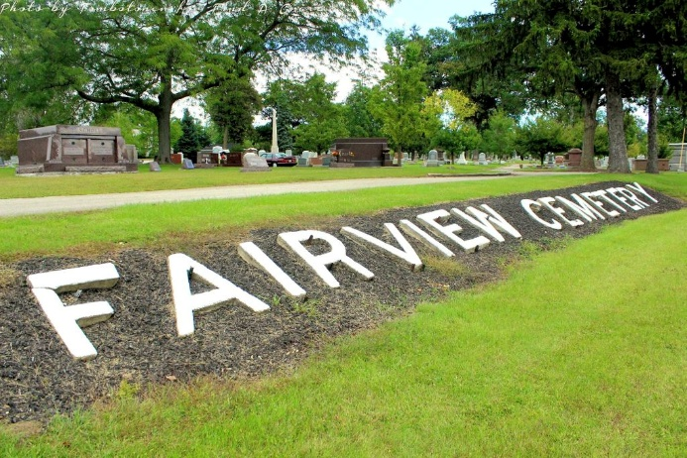
Photo by Tombstoner & Family

JOHN O. KUNKEL DIES AT DAUGHTER'S HOME
DEATH OCCURS SUDDENLY OF HEART ATTACK
FUNERAL TO BE TUESDAY AFTERNOON
John O. Kunkel, 87, a native of Lancaster township, and a lifelong resident of Wells county, died at 8 p. m. Saturday night at the home of a daughter, Mrs. Brooks Souder, one-half mile north of Bluffton. He had been in failing health for three months, but death came suddenly as the result of a heart attack.
The decedent had been prominent as an agriculturalist during the active years of his life, but had been retired as a farmer for a number of years and had made his home with the daughter.
Born on a farm in Lancaster township, he was a son of Michael and Mary A. Kleinknight Kunkel. His marriage to Melissa Blue took place in Bluffton Nov. 11, 1876. Her death occurred March 8, 1921.
Surviving are three sons, Fred and Reuben B. Kunkel, of Poneto, and Elzey O. Kunkel, of Sandoval, Ill., and three daughters, Mrs. Earl French, of Grand Forks, N. D., Mrs. Eva Morford, of Indianapolis, and Mrs. Brooks Souder, north of Bluffton; 14 grandchildren and two great grandchildren.
Preceding the decedent in death were four sisters and two brothers, the latter having been T. H. Kunkel and William A. Kunkel.
The body was returned this afternoon to the daughter's home from the Elzey & Son funeral home from Ossian, and funeral services will be held at the Souder home at 2 p. m. Tuesday, in charge of Rev. A. S. Elzey, of Ossian. Burial will be in Fairview cemetery. Friends are asked to omit flowers.

Evening News-Banner, Wells County, Indiana
Monday, March 25, 1940, P 1, C 6

