John Edward Kunkel
August 18, 1872 – March 20, 1914

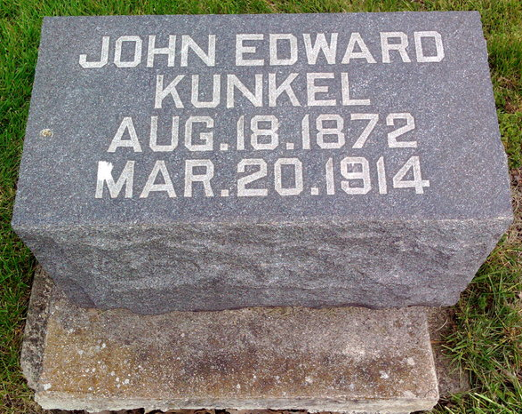
Photo by Thomas Liby

TELLS OF DEATH OF EDWARD KUNKEL
MARION PAPER TELLS OF FATAL ILLNESS
FUNERAL HERE MONDAY.

John Edward Kunkel, aged 41, for more than fourteen years a clerk in the shoe department of the Blumenthal store, died about 2 o'clock this morning, following a short illness of pneumonia.
The deceased is survived by the widow, a daughter, Maurine Agnes, a son, Paul, father and mother, Mr. and Mrs. Calvin Kunkel, of Wells County, two brothers, C. W. Kunkel, Wells county, and Frank Kunkel, North Manchester, and one sister, Mrs. John Smith, of Bluffton.
The funeral probably will be held Monday, with the Masonic lodge in charge. The body will be taken to Bluffton for burial.
The deceased man, who had been in charge of the women's shoe department of the Blumenthal store for years, became ill Saturday, March 7. His illness of pneumonia followed an acute attack of inflammatory rheumatism. His condition had been serious for about two weeks, although up to the night of his death, he appeared to be improving.
John Edward Kunkel was born August 18, 1872, in Ossian, Wells county, Ind. He was well and popularly known in Marion and Grant county. His former employer, David Blumenthal, said of the deceased: "He was a first class man in every way, and one of our best men," in a few words, the best that could be said of any man. Mr. Kunkel was a member of the local lodges of K. of P. and Masons.
Rev. Thomas Gray, pastor of the Congregational church, will conduct services at the deceased man's late home at 513 West Fifth street, at 8:30 o'clock the day of the funeral. The body will be shipped to Bluffton at 9:30 o'clock, where Rev. Arnold will conduct a short service over the body at the M. E. church. - Marion Chronicle.
The funeral party will arrive in Bluffton over the M. B. & E. Monday forenoon, on the 10:45 car, and will go direct to the First M. E. church, where the funeral services will be conducted. The Marion lodge of Masons will have charge of the Masonic rites at the funeral and members of the Bluffton and Warren Masonic lodges will be in attendance. The deceased was a member of the Warren lodge of Masons.

Evening News, Bluffton, Wells County, Indiana
Saturday, March 21, 1914, p. 2, C. 2
**

ED KUNKEL DEAD - At Marion - Ill of Pneumonia
Son of Mr. and Mrs. Calvin Kunkel - OF NEAR TOCSIN
Has Relatives Here - Funeral Will Be Monday At Bluffton

Ed Kunkel, a former Bluffton clerk, son of Mr. and Mrs. Calvin Kunkel, residing near Tocsin, a relative of the Kunkels residing here, died yesterday at his home at Marion, from pneumonia. The funeral will be held in Bluffton on Monday morning. The funeral party will leave Marion at 9:30 o'clock over the M. B. & E. and on arrival at Bluffton the services will be held immediately in the M.E. church. Rev. W. T. Arnold and the Masons will have charge of the services and the interment will be in the Fairview cemetery, where some of Mr. Kunkel's relatives are buried.
Mr. Kunkel was twice married and one wife and one child have preceded him in death. His second wife and two children, a daughter of the first marriage, and a son of the second, survive him, together with his parents and the following brothers and sisters: Frank Kunkel who recently moved from Bluffton to North Manchester; Charles Kunkel, residing near Tocsin, and Nellie, wife of John Smith, of Bluffton.

Decatur Daily Democrat, Adams County, Indiana
Saturday, March 21, 1914
**

John Edward Kunkel from tree Piepenbrink Family Tree
Birth 18 Aug 1872 Wells, Indiana, USA
Marriage 1903 Pike, Indiana, USA
Residence 1910 Marion, Grant, Indiana, USA
Death 20 Mar 1914 Marion, Grant, Indiana, USA
Father Calvin Kunkel (1846-1922)
Mother Sarah A Plummer (1843-1914)
Spouse Mae Tillman (1876-1902)
Spouse Maude Ellen Crowley (1877-1865)
124 People 9 Records 19 Sources
**
Indiana, U.S., Marriage Index, 1800-1941
Name John E. Kunkel
Marriage Date 28 Sep 1898
Marriage Place Grant, Indiana, USA
Spouse Name Mae Tillman

