Mark Steven Kuhn
March 26, 1957 – May 25, 2017

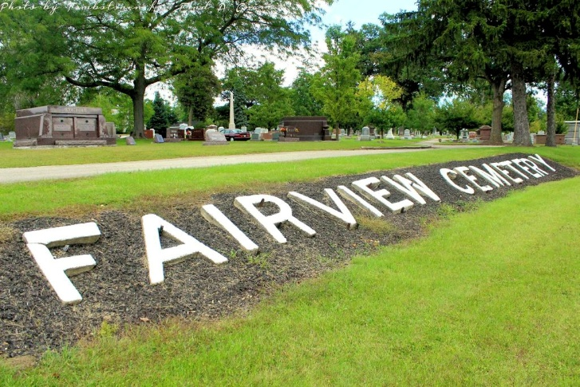
Photo by Tombstoner & Family

Mark Steven Kuhn, 60, of Bluffton passed away on Thursday afternoon, May 25, 2017, at his residence.
Mark was born on March 26, 1957 in Bluffton to Philip D. Kuhn and Barbara L. (Young) Kuhn. He graduated from Norwell High School with the class of 1975. He worked for Energy Control in Ossian for over 14 years and was currently working for K & M Asphalt Company. He loved spending time outdoors and fishing with his family.
Survivors include his father Philip of Fort Wayne, his mother Barbara of Ossian along with his son Austin Steven Kuhn of Ossian and companion Chris L. Swafford of Bluffton, along with his brother Scott (Debra) Lynn Kuhn of New Haven. He is preceded in death by his brother Duane Philip Kuhn.
A private family service has been held at the Thoma/Rich, Lemler Funeral Home, with Pastor Steve Bard officiating.

Thoma/Rich, Lemler Funeral Home, Wells County, Indiana
May 26, 2017

