Valerie E. (Perry) Krumrine
June 16, 1926 – November 25, 2016

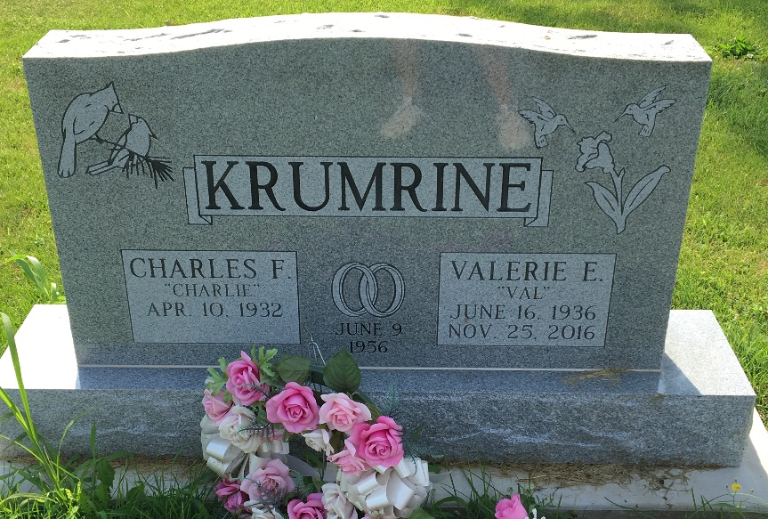
Photo by Scott Shoup

Valerie E. Krumrine, 80, of Bluffton passed away on Friday, November 25, 2016, at Lutheran Hospital in Fort Wayne.
Mrs. Krumrine was born on June 16, 1936 in Corning, New York to Fred William and Hazel (Boroughs) Perry. A homemaker, she attended Corning North Side High School and also completed some courses at Ivy Tech in Fort Wayne.
She was a member of the First Presbyterian Church in Bluffton where she served as a deacon along with serving as the President of the American Legion Post #111 Auxiliary, and served as 4th District Auxiliary President, and was a Girl Scout leader for many years.
On June 9, 1956 in Wellsboro, PA, Valerie and Charles F. Krumrine were married. Survivors include her husband of 60 years, Charles of Bluffton and children: Charles Michael (wife Martha Ann) Krumrine, Dana Francis Krumrine and Shannon Loreen Krumrine, all of Bluffton.
She is preceded in death by her parents along with four brothers: Fordyce, Lloyd, Dale and Lyle Perry.
A service to celebrate Valerie’s life will be held at 10:30 a.m. on Wednesday (November 30, 2016) at the First Presbyterian Church in Bluffton. Rev. Carol Pierson will officiate. Calling hours will be held from 2 p.m. to 8 p.m. on Tuesday at the Thoma/Rich, Lemler Funeral Home in Bluffton. Burial will take place at Fairview Cemetery in Bluffton.
Memorials may be made to the First Presbyterian Church Deacon’s Fund.
Thoma/Rich, Lemler Funeral Home, Wells County, Indiana
November 26, 2016

