Charles F. Krumrine
April 10, 1932 – June 16, 2020

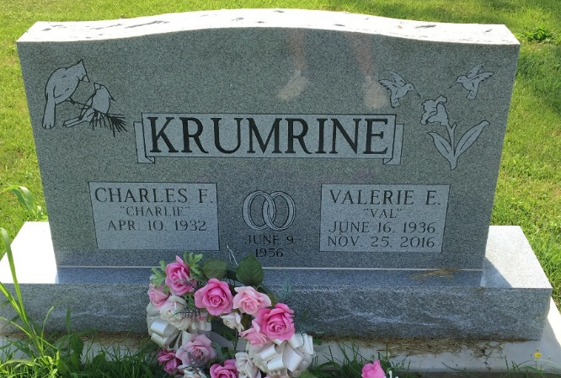
Photo by Scott Shoup

Charles “Charlie” F. Krumrine, 88, of Bluffton passed away at Signature Health Care of Fort Wayne on Tuesday morning, June 16, 2020.
Charlie was born on April 10, 1932 in State College, PA., to William R. Krumrine & Marian (Orr) Krumrine-Grossenbacher. He graduated from Wellsboro High School in 1949 and entered the National Guard in 1951. Charlie served our country in the United States Army where he was honorably discharged. He was a member of the First Presbyterian Church in Bluffton and served as a Past Commander of the of the American Legion Post #111 and 4th District Commander, where he served for 2 terms. Charlie worked for Corning Glass from 1951 and retired in 1992.
On June 9, 1956 in Wellsboro, PA, Charlie and Valerie (Perry) were married. They celebrated 60 years of marriage together before she preceded him in death on November 25, 2016.
Survivors include three children: Charles Michael (wife Martha Ann) Krumrine, Dana Francis Krumrine and Shannon Loreen Krumrine, all of Bluffton. He is preceded in death by his parents.
The safety of the family and all visitors are our utmost priority. For everyone’s safety, we ask that you practice social distancing and masks are encouraged during your visit. We appreciate your cooperation and patience.
A service to celebrate Charlie’s life will be held at 10:00 a.m. on Saturday (June 20, 2020) at the First Presbyterian Church in Bluffton with Rev. Lyle Ewing officiating. Calling hours will be held from 4 p.m. to 8 p.m. on Friday (June 19, 2020) at the Thoma/Rich, Lemler Funeral Home in Bluffton. Burial will take place at Fairview Cemetery in Bluffton with military graveside rites by the American Legion Post #111 Honor Guard.
In Lieu of Flowers, the family would prefer memorials may be made to the First Presbyterian Church or American Legion Post #111 Honor Guard.
Thoma/Rich, Lemler Funeral Home, Wells County, Indiana

