Wayland Eugene Krieg
March 13, 1926 – February 16, 1991

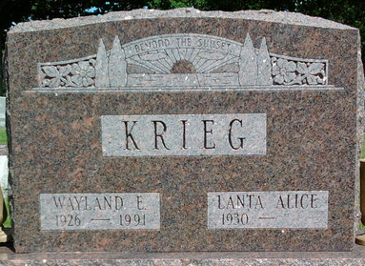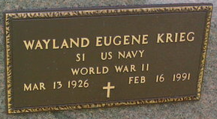
Photo by Annie (Kunkel) Hoffmeier Photo by Thomas Liby

Indiana, U.S., Death Certificates, 1899-2017

Name Wayland Eugene Krieg
Gender Male
Race White
Marital Status Married
Age 64
Birth Date 13 Mar 1926
Birth Place Wells County, Indiana
Death Date 16 Feb 1991
Death Place Fort Wayne, Allen, Indiana, USA
Death Registration Date 1991
Father Raymond Krieg
Mother Anna Haus
Spouse Lanata Alice Gehrett Krieg, informant
Burial 2/19/1991 Ft. Wayne Crematory

