Lanta Alice (Gehrett) Krieg
April 15, 1930 – June 20, 2019

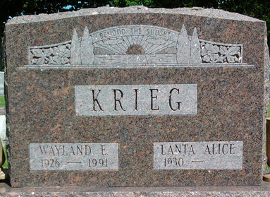
Photo by Annie (Kunkel) Hoffmeier

Lanta Alice Krieg, 89 of Ossian passed away on Thursday morning, June 20, 2019, at Ossian Health & Rehab Center. Alice was born on April 15, 1930 in Grand Rapids, Michigan to Harry Samuel & Ruth Esther (Reber) Gehrett.
A lifelong Wells County resident, she attended P.A. Allen High School and worked as a cook and bartender at Oil City Tavern. Alice also worked at Billy Ann’s and the Wayne Wood Inn in Fort Wayne. She was a member of the Bluffton Moose Lodge and the American Legion Post #111 Auxiliary since 1966.
On October 29, 1965 in Kentucky, Alice and Wayland Eugene Krieg were married and he preceded her in death on February 16, 1991.
Survivors include 2 children; Connie Medsker and Richard (Diana) Houdyshell, both of Fort Wayne along with seven grandchildren and four great-grandchildren. She is also survived by siblings; Ethel Medsker of Fort Wayne, Harriett Bennett of Bluffton, Mary Jane Kessler of Fort Wayne, Karen Hartman of Montpelier and Sharon Uhle of Michigan and George Gehrett of Bluffton and Richard Lee of Michigan.
Alice is preceded in death by three sons; Patrick, Martin and Harry Houdyshell, a grandson, Josh and a sister, Bernice Dean.
Services will be held at 10 A.M. Monday (June 24, 2019) at the Thoma/Rich, Lemler Funeral Home in Bluffton with Rev. Lyle Breeding officiating. Burial will follow at Fairview Cemetery in Bluffton.
Calling hours will be from 12 Noon to 5 P.M. on Sunday at the funeral home, and for one hour prior to the service on Monday.
Memorials may be made to the Friends of the Wells County Animal Shelter.

Thoma/Rich Funeral Home, Wells County, Indiana
June 20, 2019

