Timothy A. Kinsey
April 31, 1957 – May 15, 2018

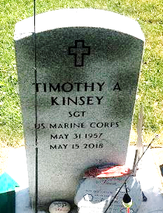
Photo by SMMR

Timothy A. Kinsey, 60 of Bluffton passed away on Tuesday evening, May 15, 2018, at Lutheran Hospital in Fort Wayne. He was born on May 31, 1957 in Georgia to Charles “Pete” & Lizzie Lovenia (Martin) Kinsey and graduated from Bluffton High School in 1976. Tim served our country in the United States Marine Corps from Dec. of 1976 to Feb. of 1983, and was honorably discharged with the rank of E-5.
Tim touched many lives with his helping hands and generosity. He was an avid fisherman who also loved hunting, gardening and being surrounded by family and friends. He was employed by several local businesses including the Bluffton Foundry, TI Automotive, and Thunderbird.
Tim will be remembered by his three daughters; Cynthia (Joseph) Looney of Elkhart, Rebecca (Joshua) Wamsley of Columbia City, and Ashley Kinsey of Huntington. He was a loving grandpa to 7 grandchildren; Faith Ann Looney, Lee Looney, Cohen Wamsley, Declan Wamsley, Haley Rohde, Rebecca Rohde and Jonathan “Buck” Rohde. Other survivors include his siblings; Randy H. Kinsey of Bluffton, Lorrie (Jason) Cox of Bluffton, Darlene (Jason) Johnson of Decatur and several loving nieces and nephews.
He is preceded in death by his parents and a brother Tony P. Kinsey.
A service to celebrate Tim’s life will be held at 1 P.M. on Sunday (May 20, 2018) at the Thoma/Rich, Lemler Funeral Home in Bluffton with Pastor Dan Eckelbarger officiating. Calling hours will take place on Saturday from 12 Noon to 6 P.M. at the funeral home and for one hour prior to the service on Sunday. Burial will take place at Fairview Cemetery in Bluffton with Military Honors by the American Legion Post #111 of Bluffton and the United State Marine Corps Honor Guard.
Memorials may be made in memory to the family through the funeral home.

Thoma/Rich, Lemler Funeral Home, Wells County, Indiana
May 17, 2018

