Penelope D. Keyser
July 20, 1881 – December 8, 1900

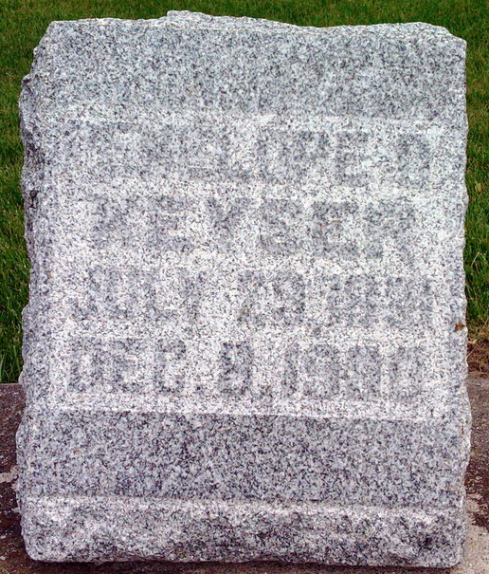
Photo by Thomas Liby

Dies Suddenly – We copy the following account of the sudden death of Miss Penelope Keyser from the Bluffton, Ind., News:
The home of John Keyser and wife on West Wiley Avenue is a saddened one, the first death in the experience of the family occurring when their daughter, Penelope, was suddenly called away. Her death came Saturday night at nine o’clock. She had been up town and had gone home but an hour previous to her death. The young lady had retired at nine o’clock after spending the evening with her brother, Clement, and five minutes later, Mrs. Keyser was aroused by the sounds of groans, and hurrying to her bedside found her dying. She had been subject to slight attacks of heart trouble and hemorrhages.
Miss Penelope was born in Monroe county, Ohio, July 20, 1881. She came with her parents to Bluffton nine years ago. During the pastorate of Rev. Light, three years ago she became a member of the Methodist church and was a devout Christian follower, a member of the Luagne and of Miss Laura Conklin’s class. Resolution were read to her memory by the class at the Sunday school hour.
The funeral was held from the Baptist church at two o’clock this afternoon, with Rev. Light in charge and interment followed in Fairview cemetery.

Spirit of Democracy, Woodsfield, Ohio
December 20, 1900

