L. Jennie (Prillaman) Kapp
November 30, 1859 – November 1, 1936

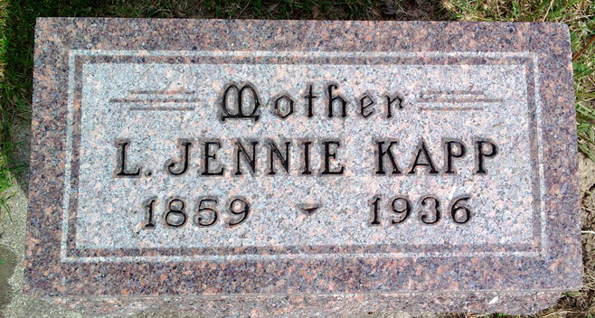
Photo by Thomas Liby

Bluffton, Nov. 2 – Funeral services will be held at 2 pm Tuesday for Mrs. Jennie Kapp, whose death yesterday followed an illness from heart disease. She was a member of the First M.E. Church of this city.
Surviving are the husband; three sons, Homer, Harry and George Kapp, all of Bluffton; and a daughter, Mrs. John Strohm of Alameda, Cal.; a brother, William Prillaman, east of Bluffton; and five sisters, Mrs. J. A. McBride, Mrs. John Bixler and Mrs. Robert Chalfant, all of Bluffton; Mrs. R. A. Brown of Huntington and Mrs. Lon Wilkie of Detroit.
Funeral services will be in charge of the Rev. P. B. Smith and burial will be in Fairview Cemetery.

Fort Wayne Journal-Gazette, Allen County, Indiana
November 3, 1936, Page 20
**

Indiana, U.S., Marriage Certificates, 1960-2012
Name Jennie L Prillaman
Gender Female
Marriage License Date 22 Jul 1882
Marriage Date 23 Jul 1882
Marriage Place Wells, Indiana, USA
Spouse Charles A Kapp

