Charles A. Kapp
February 8, 1939 – December 24, 1939

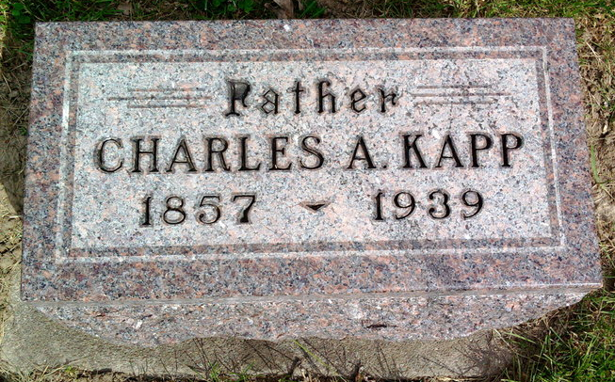
Photo by Thomas Liby

Indiana, U.S., Death Certificates, 1899-2017
Name Charles A. Kapp (Indexed as Kopp)
[Charles A. Kapp]
Gender Male
Race White
Marital Status Widower
Age 82 y 9m 16d
Birth Date 8 Feb 1857
Birth Place Vera Cruz Wells Co Indiana
Death Date 24 Dec 1939
Death Place Nottingham, Wells, Indiana, USA
Death Registration Date 1939
Father Leonard Kopp
Mother Martha Smith
Spouse Jennie Prillaman Kopp
Informant George Kapp, Bluffton, IN
Burial Fairview, Bluffton, IN

