Earl Leroy Kahn
June 19, 1939 – October 17, 2017

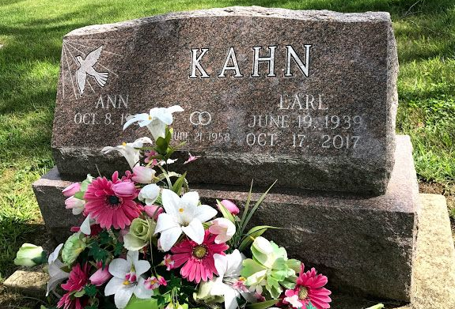
Photo b SMMR

Earl Leroy Kahn, 78, passed peacefully at home Tuesday, October 17, 2017. Born in Murray, he was a son to the late Clarence Kahn and Flossie (Ramsey) Kahn-Holmes. He graduated from Bluffton High School and then obtained his barber license. Earl, along with the late Denny Armey, were owners of Diplomat Sty-Lon for over 50 years. He was a member of the Summit City Barber Shop Quartet. During his retirement he was a greeter at Covington Funeral Home. He was a member of Avalon Missionary Church.
He is survived by his wife of almost 60 years, Elizabeth "Ann" Kahn of Fort Wayne; sons, Stuart and David Kahn both of Fort Wayne; grandchildren, Seth, Shane, Erica, Nick and Nina; and siblings, Virgil Kahn of Bluffton, Hilda Baumgartner and Rose Ann King both of Veracruz.
He was preceded in death by a daughter in law, Rhonda Kahn; brothers, Clarence "Cat Fish", Robert "Strawberry" and Lester Kahn; and a sister, Marybell Baumgartner.
Funeral Service is 11:00 a.m., Saturday, October 21, 2017 at Avalon Missionary Church, Main Campus, 1212 Lower Huntington Road, with calling one hour prior to the service. Officiating will be Pastor Matt Bruce. Calling is also 4-8 p.m., Friday at Covington Funeral Home, 8408 Covington Road. He will be laid to rest 3:00 p.m., Saturday at Fairview Cemetery in Bluffton. Preferred memorials are to the church.

Covington Memorial Funeral Home, Allen County, Indiana

